he Official Publication of ALOA—An International Association of Security Protessionais



A Locksmith’s Life at NASA  
By Chris Geary, CRL

HAPPY NEW YEAR

Blasting Off!

Breck H. Camp Cml PO Box 47070 Atlanta GA 30362-0070

I11I1.111..11II11I1.111I1I11..1II111I.11IH1..

1 1.11

Plus:

History of Auto Keys, Going in the Side Door,  
Helping out on a Re-Hanging,

This Ain’t Your Daddy’s Locksmith Business,

Safe Servicing and Combo Changing (Part 1 of 3), and more

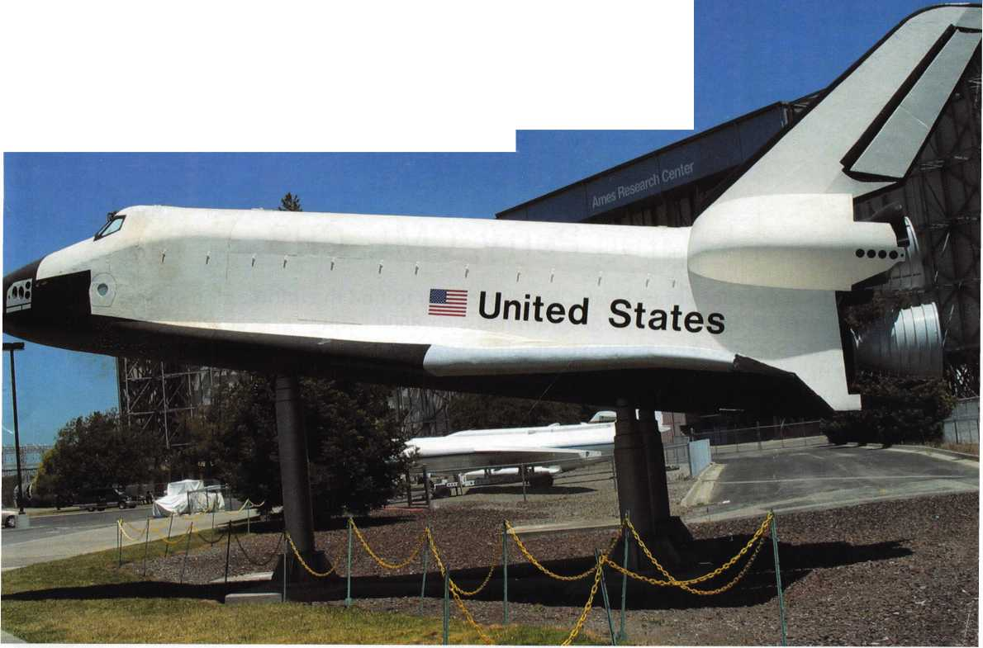

SafeData

Greg Perry, CML, CPS

Open up your library! SafeData allows you to find the information you've  
invested in, fast. This one program has over 8500 listings of magazine, books,  
ClearStar Security Network posts and my personal library. Each listing includes not  
only the book or magazine, the issue, the title, the author and the page, but it also  
lists the lock and the hand of the lock (when available). SafeData lists patent dates  
and other trivia that may help in identifying a container or lock.

SafeData also has picture folders representing over 90 different manufactures of  
safes and locks with over a thousand pictures. Some models include a text file giv-  
ing general information on size and relock locations. Plus you can add your own  
information and update it yourself or purchase the annual updates.

SafeData is available exclusively from ALOA. Normal price for this CD is $249.95.  
Price includes two installs! Put it on your desktop and your laptop.

Special Introductory offer

includes your first update!

$199.95

To order contact ALOA (800) 532-2562



Your Future

Join us next summer at the East Coast's premiere travel destination as we set the stage for the biggest security event in the world. Come to Baltimore and discover classes, workshops, and exhibits that will help you shine in today's marketplace.

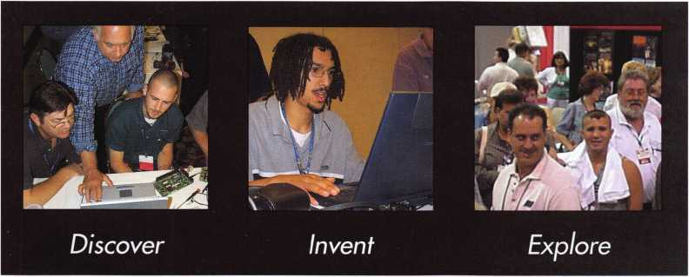

moke, wi?

get it... together

The ALOA Convention and Security Expo • Baltimore Convention Center • July 1 9-25, 2004 • (800)532-ALOA(2562)

[convention@aloa.org](mailto:convention@aloa.org) • [www.aloa.org](http://www.aloa.org)

presidential

viewpoint

Dear members,

I trust that everyone had an enjoyable holiday season and is looking forward to a produc-  
tive and prosperous new year. Over the holidays, I was invited to several associations'  
holiday events. I enjoy getting out and talking to locksmiths, and one group in particular  
deserves some special recognition.

I was guest speaker at the Christmas banquet of the Delaware Valley Chapter of the Insti-  
tutional Locksmiths Association, which was held in Philadelphia, PA. The ILA is a national  
organization and has three local chapters that meet regularly: Delaware Valley, Great

Lakes, and Northern Arizona. They have an annual convention and educational opportuni-  
ties scheduled throughout the country uniting their membership.

The ILA struggled in its infancy, but is now doing quite well under strong leadership. I have known the national pres-  
ident, Tom Negron (employed by the New Jersey State Police) for some time, as well as many of the members of  
the national board. They are a great group of individuals who put their members' interest at the forefront.

ILA is a very valuable ally to ALOA. ILA locksmiths control more doors and openings and have more buying power  
than all of the locksmiths in the private sector combined. They have tremendous influence with manufacturers, which  
leads to great educational opportunities. They have developed a certification program similar to the PRP that is tai-  
lored to the type of locksmithing that the "in house" guys do.

ALOA wants to continue to foster a good working relationship with ILA. I have invited Tom to the spring board  
meeting to share ideas, and I am also seeking to have an ILA director who would be willing to serve on the ALOA  
Board. We want to help ILA with any additional educational needs that they may have, and assist in their certifica-  
tion program if the need arises. We would also encourage the ILA members to join our ranks and feel that the cre-  
ation of a corporate (or company) membership will prompt the institutional employers to have all of their locksmiths  
become ALOA members.

I commend the efforts of ILA and other organizations that cater to the needs of specialty groups in our field. Another  
group that comes to mind is the International Association of Investigative Locksmiths. ALOA will continue to work to  
meet the needs of locksmiths who specialize in specific areas such as access control or automotive work. And of  
course, SAVTA meets the needs of our safe tech partners.

Sincerely,

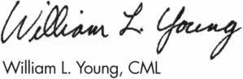

Keynotes • January 2004

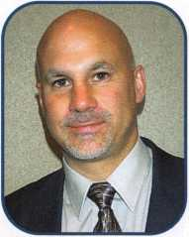

executive

Volume 50, Issue 1



Additional contact information for the ALOA Board and most Keynotes authors is available through "Locksmith Search'" on the ALOA Web site- [www.aloa.org](http://www.aloa.org) or by contacting the ALOA office at 3003 Live Oak Street; Dallas, TX 75204; (800)532-2562; FAX (214)827-1810; e-mail [aloa@aloa.org](mailto:aloa@aloa.org).

|  |  |
| --- | --- |
| Editor  Jim DeSimone | [editor@aloa.org](mailto:editor@aloa.org) |
| Technical Editor  David Lowell, CML, CMST .... | [david@aloa.org](mailto:david@aloa.org) |
| Editorial Advisor  John D. Cannon, CML | [jdcannon@worldnet.att.net](mailto:jdcannon@worldnet.att.net) |
| Art Director  Betty Henderson | [betty@aloa.org](mailto:betty@aloa.org) |
| Advertising Sales  Kim Hammond | voice: 817-645-6778  Fax: 817-645-7599 e-mail: [adsales@aloa.org](mailto:adsales@aloa.org) |
| Executive Director  Charles W. Gibson, Jr., CAE | [charlie@aloa.org](mailto:charlie@aloa.org) |
| Convention & Meetings Manager  Jo Anne Mims [joanne@aloa.org](mailto:joanne@aloa.org) | |

PRP/Education Manager

David Lowell, CML, CMST [david@aloa.org](mailto:david@aloa.org)

Operations/Membership Manager

Mary May [mary@aloa.org](mailto:mary@aloa.org)

Government Relations Manager

Paul Kanitra [paul@aloa.org](mailto:paul@aloa.org)

IT Operations Manager

Greg Jackson [greg@aloa.org](mailto:greg@aloa.org)

Comptroller Kathy J. Romo

Membership Coordinator Shelly Jett

Convention & Meetings Assistant Karen Lyons

PRP/Education Coordinator Esperanza Rodriguez

Accounting Coordinator Stephanie Brothers

Mail Room Coordinator Kevin Wesley

Receptionist Bryan Dease

Contributors

Jerome Andrews, CML Paul Chandler, CRL Claire Cohen, CML Brian Costley, CML, CMST Eric Costley, CRL

Ray D'Adamo, CML Sal Dulcamaro, CML Billy Edwards, CML Dan Graffeo, CRL,CMST Jim Hancock, CRL

AJ. Hoffman, CML Jeff Nunberg, CML, CMST Randy Simpson, CML Robert Stafford, CML Dave Thielen, CML

Greg Perry, CML,CPS Tom Seroogy Charles Stephenson, CPS Dennis Watanabe, CML, CMST

**Mission Statement:** The Associated Locksmiths of America, Inc. is dedicated to enhancing the professionalism, education and ethics among locksmiths and those in related sectors of the physical security industry. With approximately 10,000 members in the United States, Canada and the freeworld, ALOA is poised to help members obtain the knowledge, the strength, and the confidence to perform their role in the physical security field with pride and dignity. But it is only through active involvement and participation that ALOA can fully achieve its potential—and can help members to achieve theirs.

**Policies:** Keynotes® is the official publication of the Associated Locksmiths of America, Inc. (ALOA). Keynotes® acts as a moderator without approving, disapproving, or guaranteeing the validity or accuracy of any data, claim, or opinion appearing under a byline or obtained or quoted from an acknowl­edged source. The opinions expressed by the authors do not necessarily reflect the official views of ALOA. Also, appearance of advertisements and new products or service information does not constitute an endorsement of products or services featured by the Association. The Association does not accept responsibility for the inaccuracy of any data, claim, or opinion appearing in this publication, due to typographical errors on the part of the authors, Association staff or its agents.

**Editor's Note:** This publication is designed to provide accurate and authoritative information in regard to the subject matter covered. It is provided and disseminated with the understanding that the publisher is not engaged in rendering legal or other professional services. If legal advice and other expert assistance is required, the services of a competent professional should be sought.

**Authors' Payment:** Payment for eligible submissions to Keynotes will be based on the following criteria: topic, time spent and past contributions. Authors who regularly submit to Keynotes® are generally paid a higher rate. The latter is especially true of authors who write to fit specific editorial needs and submit said copy by Keynotes® deadlines. As a general guideline: Average payment for a 750 word, business or 'light' technical article would be $200. Payment for a 1500 word article involving significantly higher time and research efforts would be $400.

Payment will not be offered for articles submitted by ALOA employees or members of the ALOA Board of Directors (unless material is of a technical nature), nor for articles submitted by a company that promote that company's products or services. ALOA reserves the right not to pay for articles sub­mitted by an individual(s) that promote a particular company's products or services.

**Disclaimer:** The Associated Locksmiths of America, Inc., (ALOA), reserves the right to refuse any article for any reason. Additionally, ALOA reserves the right to edit, amend or modify any article submitted for publication in order to preserve technical accuracy, clarity, fairness or grammatical cor­rectness. ALOA will make the best efforts to notify the author of any changes. The extent of ALOA's liability for any article or information contained therein will be a notice of correction or retraction in the next possible issue.

Keynotes® (ISSN 0277 0792) is published monthly except for the combined June/July issue by The Associated Locksmiths of America, Inc., 3003 Live Oak St., Dallas, TX 75204-6186. Telephone: (214) 827-1701; FAX (214) 827-1810; e-mail [aloa@aloa.org](mailto:aloa@aloa.org). Subscription rates for members—$15.00 per year. Periodical class postage paid at Dallas, Texas. POSTMASTER: Send address changes to: Keynotes, 3003 Live Oak St., Dallas, TX 75204-6186. © Copyright 2003, All rights reserved. No part of the contents may be reproduced or reprinted in any form without prior written permission of the publisher.

M

President

William L. Young, CML  
(610)647-5042  
president@aloa. org

Secretary

John D. Cannon, CML  
(703) 960-6413  
secretary@aloa .org

Directors, Northeast

Robert E. Mock

(856)863-0710  
nedi rector@aioa .org

Peter Sarailian, CRL  
(973)890-9797  
nedirector@aloa .org

William L. Young, CML  
(610) 647-5042  
nedirecfor@aloa .org

Directors, Southeast

Tom Gillingham, Jr., CML, CPS  
(615)264-0747  
[sedirector@aloa.org](mailto:sedirector@aloa.org)

Ken Ku pferman, GPL  
(813)961-5784  
[sedirector@6ba.org](mailto:sedirector@6ba.org)

Directors, North Central

Mark E. Blum, CML, CPS  
(517) 482-5809  
[ncdirector@aloa.org](mailto:ncdirector@aloa.org)

John Soderland, CML, CMST  
(414) 327-5625  
n cd i rector@a loa. org

Director, South Central

CD Lipscomb, CML, CPS

(903)874-3522  
scd irector@aioa. org

Directors, Southwest

Gordon R. Racine, CML  
(719) 384-4707  
swdirector@aloa .org

Julie McCluney, CRL

(714) 636-5652  
[swdirector@aloa.org](mailto:swdirector@aloa.org)

Director, Northwest

Scott L Henke CPL, CPS  
(907) 248-3785  
nwdirector@aloa .org

Director, European

Hans Mejlshede, CML  
(453)539-3939  
eurdirecfor@a loa. org

Director, Asian

JoeJ. Lee, CRL  
(215)289-2404  
[asiandirector@aloa.org](mailto:asiandirector@aloa.org)

Director, Associate

Paul M. Justen  
(800)333-6953  
[asdirector@aloa.org](mailto:asdirector@aloa.org)

Trustees

[trustees@aloa.org](mailto:trustees@aloa.org)

Randy Simpson, CML  
(281 )240-5959

John J. Greenan, CML, CPS  
(773) 486.2030

Dallas Brooks  
(334) 826-8990

Past Presidents

2001-2002 Randy Simpson, CML  
1999-2001 John Greenan, CML, CPS  
1997-1999 Dallas C. Brooks  
1995-1997 David Lowell, CML, CMST  
1993-1995 Breck Camp, CML  
1991-1993 Henry Printz, CML  
1989-1991 Evelyn Wersonick, CML, CPS  
1987-1989 Leonard Passarello, CPL  
1985-1987 Joe Jackman, CML  
1983-1985 Stanley Haney, CPL  
1981-1983 Louis LaGreco, CPL  
1979-1981 John Kerr, RL  
1977-1979 Clifford Cox, CML  
1974-1977 Charles Hetherington  
1972-1974 Gene Laughridge  
1970-1972 William Dutcher, RL  
1968-1970 Constant Maffey, RL  
1966-1968 Harold Edelsfein, RL  
1964-1966 William MeacHam  
1962-1964 Robert Rackliffe, CPL  
1960-1962 Edwin Toepfer, RL  
1956-1960 Ernest Johannesen



Keynotes • January 2004

f

u

r

e

s

e a

t



departments

Executive 3

Applicants 6

Calendar 8

Core 1 0

Legislative Update 38

Classifieds 40

Associate

Members 42

Back Page 44

**12**

Institutional Locksmithing at the NASA Ames Research Center, California

What are the ingredients of the perfect locksmithing job? Consider a combination of regular hours, nice customers and zero bounced checks or overdue accounts. Add to that a mixture of an inexhaustible supply of steady work and an exciting and rewarding work environment, and you'll start to get an idea of what it is like being an institutional locksmith at NASA Ames Research Center in sunny California.

By Chris Geary, CRL

**16**

A Brief (and Interesting) History of Automotive Keys

Knowing about the earliest automobile locks and keys learning a little about the automobiles themselves. For example, more than 15.5 million Model T Fords were manufactured in the United States from 1908 to 1927 - more than all other makes of automobiles. In 1914, a completed chassis was assembled every 93 minutes; in 1927, every 24 seconds.

What kinds of keys did these old beauties use?

By Merritt Perkins, RL



Helping Out on a Re-Hanging

We used the same type of hinge and fasteners as the rehanging job we did last year, but the method of installation on this job was different. We recommended what was appropriate for the customer, not because it would make us more money, but because it was needed for a reason­able amount of security. This job could be done alone, but it would take longer, and during some parts of the job, it would pose some safety issues.

By Greg Perry, CML, CPS



Going in the Side Door

Let's look at a pair of Overly vault doors. On the pair we were servicing locally, I tried the han­dle; sure enough, it would not turn, and the lock bolt was retracted, but the door still would not open. I could tell the lock bolt was retracting because of the amount of travel after the stepper motor fired inside the lock. There is no relock inside the door, so what could be keeping the door locked? What could be the problem?

By Greg Perry, CML, CPS



This Ain't Your Daddy's Locksmith Business!

Well, as I set out to write this article, it dawned on me the dramatic changes that have occurred  
throughout the evolution of automotive security. On my father's car, security was the lock and key;  
just enough to keep the honest people honest. Security during my time includes the introduction  
of high security locking systems and electronic disabling systems like VATS. Although keys were  
still widely used, my son and daughters' made their driving debut around the time of GM's  
Passlock system, and the birth of transponder technology, during what is probably the fledgling  
era of electronic automotive security. More changes, and at a faster pace than ever.

By Tom Seroogy



Safe Servicing and Combination Changing

Servicing and changing combinations on home/office safes and vault doors is a very lucrative  
part of the locksmithing industry. Though the wave of the future of our industry is electronics,  
mechanical combination locks are still in abundance in the marketplace and probably always  
will be. Let us first examine the definition of safes and how the mechanical imperfections work to  
our advantage as security professionals.

By Jim Hancock, CRL

Visit our website at [www.aloa.org](http://www.aloa.org)



*firm*

***Visit our Website on  
www. stamcctv. com***

**THE COMPLETE**

**CCTV PROGRAM ON CD-ROM  
FOR STAFF TRAINING AND**

**PRODUCTIVITY ENHANCEMENT**

STAM Insight has been  
developed to enhance CCTV  
skills and productivity with  
many different uses.

40 Productivity

10 System Drawing  
40 Estimation  
**# CCTV** Training  
40 **CCTV** Reference  
40 Sales/Demo  
40 System Design  
40 Staff Evaluation

|  |  |  |  |  |
| --- | --- | --- | --- | --- |
|  | 1 | SNFOMATE | WORKMATE  1 |  |
| Reference | CC7V Content | 10 hours | 10 hours | [ 14 hours |
| CCTV Calculators |  | f / | w |
| Demonstration Tool | ¥ |  | : / |
| Productivity  Tool | Estimation  Drawing  Internet Enabled | No  NO  No | ¥ | f  /  / |
| o) | K Pre-Test | No | f No | i / i |
| c  c  n | Quizzes | No | f Mo | i / |
| £ | Knowledge Assessment | No | MO | 7 / |

**Sold in Over 50**

Distributed by:

3003 Live Oak Street  
Dal las, Texas 75204



■ Yes, please send me a FREE PREVIEW CD ROM $9.95 S/H

Name:

Job Title:

Organization:

Address:

Zip/Postcode

Country e-mail

Tel: ( ) Fax: ( )

COPYRIGHT © 1996 Security Training and Marketing Pty Ltd. All rights reserved ACN 057 006 541

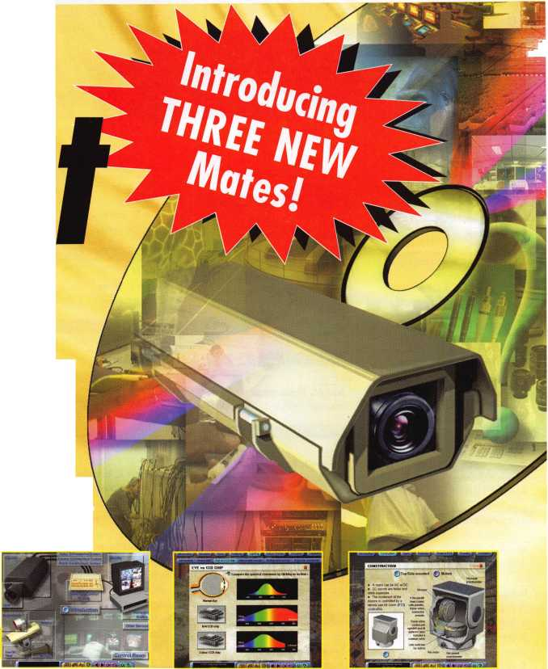

**AR**

**Rogers**

Bruce Houk

AZ

**Glendale**

Michael A. Hodge

Sponsor: William Lee CRL Mesa

Craig Tancer

Sponsor: Phillip R. Cookman CRL

Gary Virak

Sponsor: Timothy R. Shaw CML Phoenix

James G. McGowan

Sponsor: William Lee CRL Surprise

Rocco R. Monaco

Sponsor: Nicholas A. Monaco CRL

Brian Scherer

Sponsor: William Lee CRL

*CA*

**Livermore**

Mark C. Cordes

Sponsor: Brooke P. Berry CRL Lodi

William J. Glissman

Sponsor: Glenn A. Glissman CML Los Angeles

Joaquin Rodriquez

**Pleasant Hill**

James Evans

**CT**

**Bridgeport**

Andres Ruiz

Sponsor: Richard M. Bayuk Marion

Wesley Wade

Sponsor: Gilbert N. Wade CRL

**DC**

**Washington**

Robert Lee

Sponsor: Gary D. Quick CPL

**GA**

**Atlanta**

Vickie L. Evans

Sponsor: John C. Elliott Jr, CML, CPS Lovejoy

Charles J. Browning

Sponsor: Danny W. Rudd CPL Marietta

Edward A. Bulick

Sponsor: Harry K. Shelton Jr, RL

**IL**

**Chicago**

Jon M. Flaskamp

Sponsor: William E. Sherlock

**IN**

**Clayton**

Kenneth R. Alderson

Sponsor: Jim Williams CRL Indianapolis

David A. Adamson

Sponsor: Jim Williams CRL

**KS**

**Lenexa**

Terry S. Livengood

Sponsor: Roger C. Ensley CRL

**MA**

**Randolph**

Travis McMenimon

Sponsor: Barry L. McMenimon CRL

**MD**

**Columbia**

Ryan A. Cohen

Sponsor: Richard L. Cohen Germantown

Richard Kean

**NC**

**Huntersville**

David J. Jones

Sponsor: Christopher T. Picerno CPL Red Springs

Stephanie R. Melton

Sponsor: George G. Micheals

**Wilmington**

Jan S. Selfe

Sponsor: Dale E. Dalton

**NJ**

**Mount Holly**

John E. Byer

Sponsor: Robert J. Byer

**Brooklyn**

Sol Follman

Sponsor: Peter Sarailian CRL New Suffolk

Jane P. Kreiling

Sponsor: James G. Nekerman

**OH**

**Cleveland**

Joseph L. Billups Jr

Sponsor: Robert W. Duman Sr, CML Columbus

Ed Ferbrache

**Fresno**

Richard Stein

Sponsor: Patrick J. Fowler CRL Pataskala

Michael P. Fox Jr

Sponsor: Michael P. Fox Sandusky

Dale Douglas

Sponsor: Bruce W. Andres

**PA**

**Elverson**

Jason A. Blitzstein

Sponsor: Joseph J. Hedglin

*SC*

**Hilton Head Island**

B Brooks Harvey III

Sponsor: Charles L. Noe CPL

**TN**

**Dickson**

Michael Johnson

Sponsor: Kennith Moore Knoxville

Mark D. Wright

Sponsor: Marian M. Swann CRL Sponsor: Robert D. Butler

Robert E. Walters

Sponsor: John E. Simpson Nashville

Joel Brooks

Sponsor: Billy H. Braxton

**TX**

**Gilmer**

James P. Horton III

Sponsor: Tommy J. Warren CML Irving

Michael J. Ketterer

**Universal City**

Danny R. Davis

Sponsor: James L Hancock CRL Van Alstyne

Larry Clark

**UT**

**Santaquin**

Cary L Christiansen

**VA**

**Fredericksburg**

Gary W. Wilson

**Newport News**

David R. Goodman Jr

Sponsor: David R. Goodman Sr

**WA**

**Olympia**

Shane R. Golphenee

**Seattle**

Lonnie Thompson

Sponsor: Albert N. Bergman Jr Vancouver

Richard A. Corvi

Sponsor: William L Blea

Wl

**Bara boo**

Michael Krueger

Sponsor: Chuck S. Hegel CRL

**Canada**

**PQ Dorval** Vince De Rose

Sponsor: Bruce S. Nemec CML Hong Kong

**NT**

**Tai Po**

Chung Wai Lau

Sponsor: Kwok-kei Leung Israel

Beit Shemesh Tzvi Yisrael

Sponsor: Shimshon Alpert CPL

**Italy**

**Selargius**

Saba Giovanni

Sponsor: Ugo Dodi

**Japan**

**Shiroi Chiba**

Hiroshige Oide

Sponsor: Tomohiko Okuyama

**Malaysia**

**Georgetown Penang**

Lee Eng Hin

**Scotland**

**Penicuik**

Ross Watt

Sponsor: Ken Dale

n»i^F.ym»

**Beds**

Keith Lewis

These applicants are scheduled for clearance as members of ALOA. The names are published for member review and comment within 30  
days of this Keynotes issue date, respectively, to ensure applicants meet standards of ALOA's Code of Ethics. Protests, if any, should be  
addressed to the Membership Department and must be signed. Active Membership applicants (a) have worked in the industry two or more  
years. Allied Membership (AL) applicants are not locksmiths, but work in a security-related field. Apprentice Membership (AP) applicants

have worked in the industry less than two years.

Keynotes • January 2004

HjHinnm

IEBMI

HI

Ruailable as single modules (one CD and guidebook) or the full set (three CDs and three guidebooks).

Seruer uersions are  
also auailable!

FUNDAMENTALS OF:

**Self-Study Course**

**flLOR**

**SPECIRL**

**Get the award-winning  
*Fundamentals of architecture  
Doors and Hardware Self-Study  
Course* at a great price!**

The ultimate training tool for locksmiths... Now there is a complete in-house training

**program auailable! Order the** Fundamentals of architectural Doors and Hardware Self

**Study Course** three CD/guidebook series.

To order, call (800)532-2562 or Luiuiu.aloa.

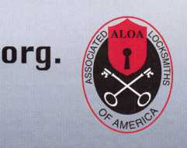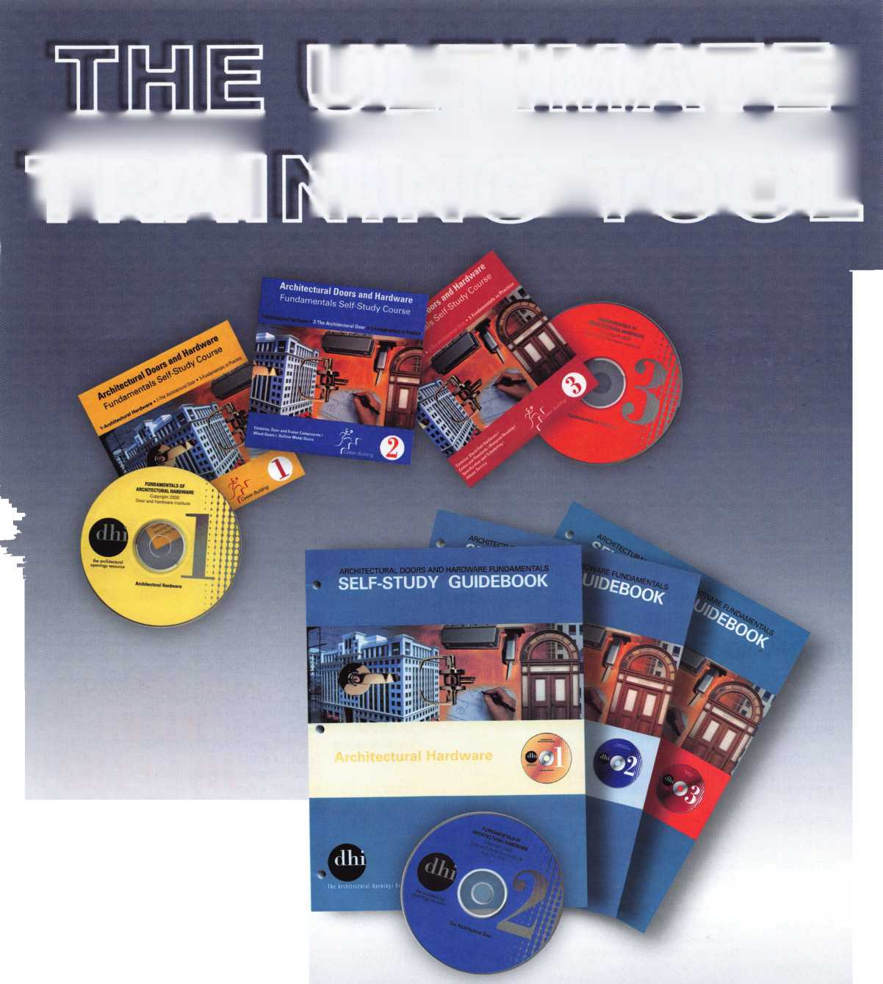

**APRIL I MARCH FEB**

upcoming events

**UPCOMING PRP SITTINGS**

|  |  |
| --- | --- |
| 1/8/2004 | Dallas, TX • ALOA  Hope Rodriguez • 800-532-2562x30 |
| 2/8/2004 | Oklahoma City, OK • OMLA Convention Mike McGrew • 918-333-9136 |
| 2/12/2004 | Dallas, TX • ALOA  Hope Rodriguez • 800-532-2562x30 |
| 2/28/2004 | Locksmith Security Assn.  Maurice Horne, CML • 313-550-5810 |
| 2/28/2004 | Colorado Springs, CO  Central & Southern CO Locksmith Assn. Gordon Racine, CML • 719-384-4707 |
| 2/29/2004 | Texas Locksmiths Assn.  Butch Titus • 210-649-2166 |
| 3/11/2004 | Dallas, TX • ALOA  Hope Rodriguez • 800-532-2562x30 |
| 3/14/2004 | Maplewood, MN  Minnesota Chapter of ALOA  Dana Lee, CML • 612-968-4500 |
| 3/27/2004 | Reno, NV • Safetech 2004  Hope Rodriguez • 800-532-2562x30 |
| 4/8/2004 | Dallas, TX • ALOA  Hope Rodriguez • 800-532-2562x30 |

|  |  |
| --- | --- |
| 4/17/2004 | Somerset, NJ • MLANJ Convention  Bill Timmann, CML • 610-253-2325 |
| 5/13/2004 | Dallas, TX • ALOA  Hope Rodriguez • 800-532-2562x30 |
| 6/10/2004 | Dallas, TX • ALOA  Hope Rodriguez • 800-532-2562x30 |
| 7/8/2004 | Dallas, TX • ALOA  Hope Rodriguez • 800-532-2562x30 |
| 7/23/2004 | Baltimore, MD  ALOA2004 Convention  Hope Rodriguez • 800-532-2562x30 |
| 8/12/2004 | Dallas, TX • ALOA  Hope Rodriguez • 800-532-2562x30 |
| 9/9/2004 | Dallas, TX • ALOA  Hope Rodriguez • 800-532-2562x30 |
| 10/14/2004 | Dallas, TX • ALOA  Hope Rodriguez • 800-532-2562x30 |
| 11/11/2004 | Dallas, TX • ALOA  Hope Rodriguez • 800-532-2562x30 |
| 12/9/2004 | Dallas, TX • ALOA  Hope Rodriguez • 800-532-2562x30 |

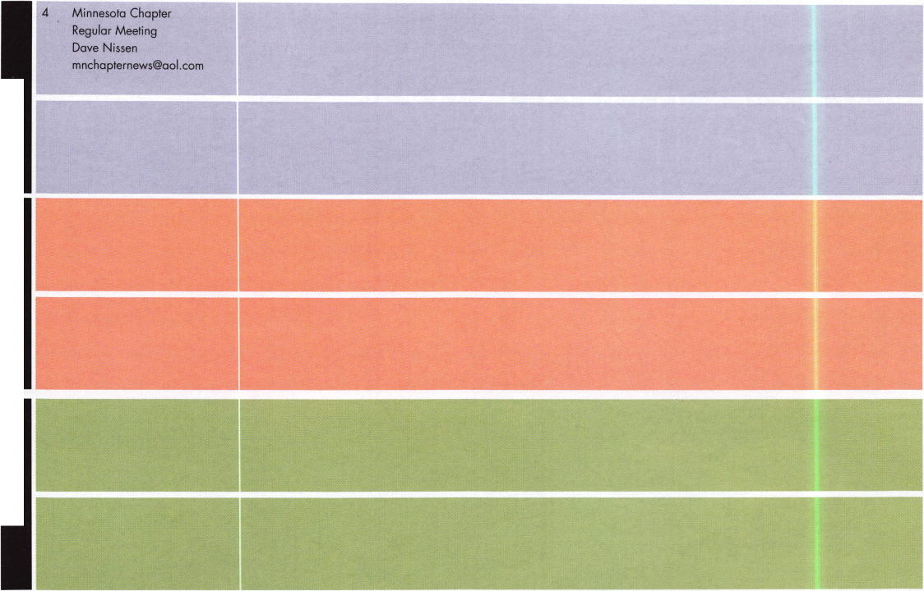

IN-STOCK...MORE SAFES

FREE Freight Program

(30 States)

AMSEC FireKing

Gardall **hayman**

MEILINK **yiCTOR**

**TURPI tO**

**WHOLESALE SERVICE**

800-848-9790

**UPCOMING ACE CLASSES**

1/10/2004

2/24-27/2004

3/12-14/2004

DETROIT, Ml • LOCKSMITH SECURITY ASSN.

MAURICE HORNE, CML • 313-550-5810

Life Safety Codes & ADA

GALVESTON, TX • TEXAS LOCKSMITHS ASSN.

Butch Titus • 210-649-2166

Investigative Locksmithing I Automotive Key Generation Electronic Safe Lock Servicing & Troubleshooting Small Format 1C • Investigative Locksmithing II Advanced Transponders • Combination Lock Servicing & Troubleshooting • Large format 1C • Investigative Locksmithing III Keyless Remotes & Automotive Update • Safe Deposit Locks Motorcycle Locksmithing • Basic Safe Penetration • Tubular Key Locks • Basic Electricity

MAPLEWOOD, MN • MINNESOTA CHAPTER OF ALOA DANA LEE, CML • 612/722-9181

Complete Door & Door Closers • Foreign Automotive (2 days) Exit Devices

7/18 - 25/2004 Baltimore, MD • ALOA 2004 Annual Convention and Security Expo 39 Seminars and Half Day Classes DAVID LOWELL, CML, CMST • 800-532-2562x18 77 ALOA ACE CLASSES [education@ALOA.org](mailto:education@ALOA.org)

10/25 - 30/2004 APPLETON, Wl • Fox Valley Technical College

Jerry Antoon P-920/735-2406 • F-920/735-2414

February 6, 2004

28th WEST COAST LOCK COLLECTORS SHOW

Embassy Suites

211 E. Huntington Dr. (off 210

FWY)

Arcadia, CA 91006 626-445-8525

$119/night includes free breakfast and happy hour

Room reservations must be made by 1/15/2004

Table fee $35, prizes for displays, admission $5, members free

Contact: A. J. Hoffman, CML

[HoffmanAJ@aol.com](mailto:HoffmanAJ@aol.com)

949-595-0666

April 24-25, 2004:

23rd ANNUAL CROSSROADS OF AMERICA SHOW

Location: Holiday Inn East 6990 East 21 st St.

Indianapolis, IN 46219 317-359-5341

Table fee $25

Contact: Pete Schaefer Phone: 317-926-3232 (business)



New Membership CD Out Now!

Be on the lookout for your renewal packets in the mail. They contain a jam-packed new CD-ROM ALOA reference tool. The CD contains a fully searchable updated ALOA Membership Directory, the ALOA Bylaws, the ALOA Code of Ethics, ALOA's Technical Standards, PRP information, an ALOA Scholarship Application, an ALOA Membership Application, information on the ALOA Convention and Security Expo, the ALOA Grievance Form, and all sorts of information on special discounts available to all ALOA members. ALOA has never put together a CD-ROM like this before, and we're very excited about delivering something as useful as this to our members' doorsteps. Look for it in the coming weeks!

MEMBERSHIP RENEWAL DEAL!!

Starting in January 2004, all ALOA members who renew for the year will receive a $15 discount off ClearStar membership (currently $45). This includes new and renewal memberships with ClearStar. Application must be made through ClearStar: [www.security](http://www.security) @clearstar.com

Let Us Know!

If you have an opinion to offer on ALOA, the state of the industry, or life in general, we want to know about it! Submissions to the "Mailbox" section of Keynotes are printed on a space-available basis. Write to: "Letters to the Editor"; ALOA; 3003 Live Oak Street; Dallas, TX, 75240; FAX 214/827-1810; e-mail: [editor@aloa.org](mailto:editor@aloa.org).

Need Help?

At ALOA, we want to make sure you are getting as much bang for your membership dues buck as we are able to give you. If you have had problems getting membership services, or have a question regarding member services, please contact Bill Gibson, exectuve director, at 800/532-2562, or e-mail: [charlie@aloa.org](mailto:charlie@aloa.org).

NEW PRP CERTIFICATIONS

DATE NAME LEVEL

10/25 Gene D. Esposito CRL

Keynotes Editorial Guidelines

1. Articles should be of a technical nature, rather than promotional. Technical arti­cles will be of more benefit to our readers, and they are more credible. Articles that are primarily promotional are not as likely to be read or believed - just as a 30-minute infomercial on television does not hold viewers' attention for very long. Furthermore, Keynotes neither accepts nor pays for previously published material as if it were an original manuscript.
2. Articles should be of sufficient length to cover the topic adequately. Generally, this ranges from 1,000 to 1,500 word, but this can vary to individual authors' needs.
3. Copy should be typed (double space) with standard margins. Articles will be typeset to fit the Keynotes format and style. This gives the publication a consis­tent and professional appearance. Authors should submit copy via e-mail, or on computer disk as a Word or Text file, if possible. If not, the author should mail a clean, clear copy. FAX copies may be accepted under certain conditions.
4. Photographs should be in color, 4X6", with the captions attached to the print. Digital photograph files are acceptable in JPEG format, and can be submitted via computer disk or e-mail. Digital files must be high-resolution, print-quality (300 dpi) (E-mail files are not to exceed 3 megabytes.) Amateur photographers may find it helpful to take their photographs outside - in early morning or on a cloudy day - using 100 to 200 ASA film.
5. Illustrations (graphics or drawings) can be included with your article. We prefer original art or drawings. No photocopies, sketches or "homemade" material will be used as original material. Material should be clear enough so that we can scan it into the computer. Camera-ready illustrations are greatly appreciat­ed. Any material submitted that has been produced by another person or com­pany must include the name of the original company with a copyright date.
6. Please submit a photograph of yourself, along with a short business biography (e.g., "Joe Q. Locksmith is the owner of Joe's Lock and Key in Upper Sandusky. He has been a professional locksmith for 15 years, and an ALOA member for 12 years. He teaches lockpicking and has obtained his CML designation.")
7. Solicited/pre-approved articles are due in the ALOA office by the 15th of the month, two months prior to the month of publication. For example, a solicited article for the December issue would be due no later than Oct. 15. Unsolicited articles must be processed by the Publications Manager, and are scheduled upon approval, in accordance with the existing article menu. Average time to publication for an unsolicited article is six months. Please indicate whether your article is time-sensitive.
8. The Associated Locksmiths of America, Inc. (ALOA) reserves the right to refuse any article for any reason. Additionally, ALOA reserves the right to edit an arti­cle for clarity, grammatical correctness and technical accuracy. Efforts will be made to notify the author of the changes, so that the author has a chance to approve the changes.

41ST ANNUAL CONVENTION & TRADE SHOW  
IN THE HISTORIC MARKET DISTRICT ON GALVESTON ISLAND  
FERRUARY 24 - 29, 2004

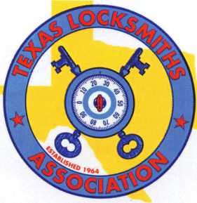

ALOA ACE CLASSES

Wednesdav, February 25,2004:

Investigative Locksmithing l Automotive Key Generation

Electronic Safe Lock Servicing & Troubleshooting Small Format 1C • P-38

Thursday, February 26,2004: Investigative Locksmithing II Advanced Transponders

Combination Lock Servicing & Troubleshooting Large format 1C • P-39

Friday, February 27,2004: investigative Locksmithing ill Remotes & Automotive Update Safe Deposit Locks Motorcycle Locksmithing • P-22 Basic Safe Penetration Tubular Key Locks • P-12

“P-#” indicates PRP certified classes

* FREE CLINICS
* FREE SEMINARS
* GENERAL MEMRERSHIP MEETING
* ELECTION & INSTALLATION

OF NEW OFFICERS

* PRODUCT EXHIBIT
* SCHOLARSHIP RAFFLE
* RANQUET DINNER, CASI NO PARTY

FOR MORE INFORMATION CONTACT:

Butch Titus, Secretary • P.0. Box 142 • Adkins, TX 78101 • 210-649-2166

1®

Institutional Locksmithing  
for the Federal Government:

**2**

Ames Research Center, California  
By Chris Geary, CRL

Keynotes • January 2004

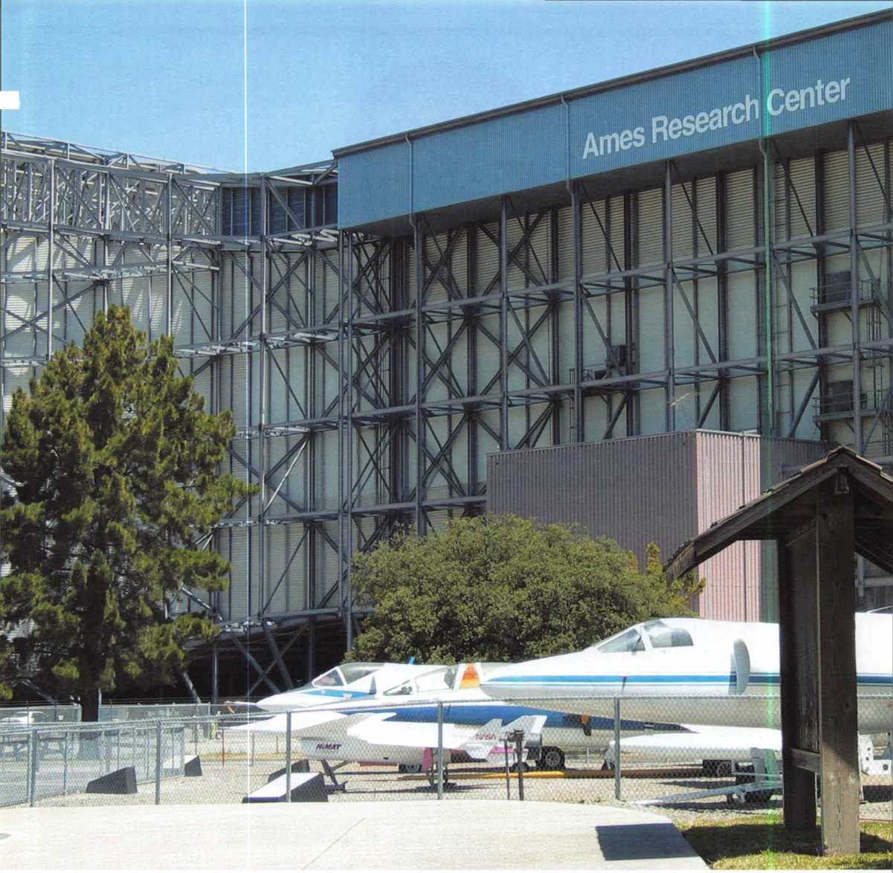

w

hat are the ingredients of the perfect locksmithing job? Consider a combination of regular hours, nice customers and zero bounced checks or overdue accounts. Add to that a mixture of an inexhaustible supply of steady work and an excit­ing and rewarding work environment, and you’ll start to get an idea of what it is like being an institutional locksmith at NASA Ames Research Center in sunny California.

Ames Research Center and the adjacent Moffett Federal Airfield are located in the San Francisco Bay Area, right in the heart of Silicon Valley. Not only was it a major naval base from the 1930s up until 1994, but also, for years, has been one of the world’s premier aeronautical research facilities. Here the largest wind tunnel in the world, named the “8o-by-i2o”, is also one of the largest electricity users in California when it is operating. Ames is also home to cutting edge research in the fields of Life Sciences, Information Technology Nanotechnology, and has entered into research agreements with a variety of universities and high-tech businesses. Hanger 1 is one of three dirigible hangers built in the 1930s for the Navy - it’s a prominent Silicon Valley landmark.

The locksmith function at Ames is split between two different departments. The Plant Engineering locksmith installs and repairs all door hardware. He also makes all keys for desks and cabinets, issues lockout/tag-out locks, and installs computer lockdown hardware. The two locksmiths in the Protective Services Technical Security Department are responsible for rekeying locks, key control, and safe work for approximately 200 buildings. Badge and card readers are not a part of our function, but are installed and maintained by contract alarm technicians.

A frequent misconception of in-house locksmiths is that we aren’t sharp enough or hard-working enough to make it in the commercial world. Ask my new partner — a commercial lock­smith for 20 years before he joined the team last November - about that misconception, and he will tell you how overwhelm­ing it has been for him. I can safely say that being a commercial locksmith does not prepare you for a great deal of what we do as a service to the Federal Government.

Keynotes • January 2004

One of our functions is to interact with the Engineering group to help develop door hardware requirements. We have made it our aim to standardize hardware as much as possible, to both cut costs and facilitate repairs. Best 9K lever sets are the standard office lock, so you can probably figure out that the base is all SFIC. While the Unican 1000 was the stan­dard stand-alone pushbutton access lock, we recently decided to switch over to the Trilogy T2 and T3 to allow for more possible combinations and flexibility.

Rekeying is a never-ending process. A combination of office moves and remodeling provides us with a steady flow of work. While we do much of the rekeying of cylinders in-house, we farm out requests for over 100 cylinders to Best Access Systems, and then install them ourselves. We computer-generate our own mas­

ter key systems, but print out the entire progression  
and work off the hard copies, which are stored in a  
GSA-rated safe. Having a complete printout allows us  
to write notes next to each code, as well as giving us  
the ability to see the whole system at one time with  
the inter-relationships of the various levels of master  
keys. We have the following key machines at our dis-  
posal: an ITL 9000 hooked up to a computer, a Rytan  
Semi-automatic, two HPC 1200CMS, three Best Key  
Combinators, and a Scotsman ACE cutter. Unlike  
most commercial shops, every key made for a door

type lock is cut on a code machine. We want to  
ensure that every key is as accurate as possible and  
will work flawlessly. That requires us to maintain an  
extensive record system.

One of the many benefits of working at a computing  
research facility is the resources available to us. We  
were provided with a relational database custom-made  
to our specifications. The government has given a  
name to our record system, RKLS, the Registered Key  
and Lock System, and it is at the heart of what we do.  
John Bousquet, a former locksmith here, did an out-  
standing job of providing the programmers with the  
overall design. The program automatically updates  
employee data from the Base’s personnel server,  
allows us to search for people by typing in any portion  
of their name, automatically inserts key requester

information for us with a click of the  
mouse, and keeps a running history of  
each key and each key holder. It dis-  
plays for us who the authorizing signa-  
tories are, and warns us if an individ-  
ual already has a copy of a key we are  
in the process of issuing. It also allows  
us to change the signatory list for  
large groups of keys all at once. It is  
built for ease of input and speed. We  
can generate custom reports by any  
one of about 30 search criteria and  
sort them any way we choose.  
Investigators, facility management,  
and contractor managers often ask us

for reports on outstanding keys for specific areas, and  
we can supply those for them in minutes. We are also  
heavy users of MS Excel and Word, PageMaker for  
keying diagrams, and a large number of other applica-  
tions. I can safely say that we make good use of com-  
puters to provide the government and our customers  
with the best service possible.

Our shop is responsible for tracking and servicing the  
safes and vaults on base. Safes are checked nightly by  
patrols, and if one is missing, we are the ones asked to



Keynotes • January 2004

track it down. Safe lockouts are a fact of life, so we have the equipment and training to both open and service them. We have a Magnum 457 and a StrongArm Mini Rig, a Vac Attack drill press, carbide

actually do more safe openings for the military ten­ants than we do for NASA, mostly because we set and service the NASA containers ourselves. We were once called out to the airfield in an emergency to meet a

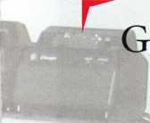

L

oing out of our way to help our customers is easy to do

because they are great to work with and appreciative

of what we do.

J



and diamond bits, an autodialer, and both Hawkeye and Stortz swing-prism borescopes. All drilling and repair is done according to FS 809. Both of us are Certified GSA Safe and Vault Inspectors. One of our most valuable tools is the ALOA-partnered ClearStar Security Network, where we can get up-to-date infor­mation on X-08 and X-09 servicing techniques, as well as get answers to any questions we have.

Since they’re in use at a Federal facility the vast majority of safes and vaults are GSA-rated, making manipulation unlikely. Even so, there are some non- rated containers that give us opportunity to practice our skills. The U.S. Navy had just vacated Moffett Field in 1994 and I found a locked vault in one of their buildings. The base commander was still on site, but was unable to track down the combination form. It was a Diebold door, circa 1930, with an unusual S&G dial having a large gap between the numbers in the drop-in zone. I detected a four-wheel lock and called the SAVTA hotline. Mike Oehlert faxed me several diagrams for comparison. It opened after an hour and a half of manipulating, turning out to be an S&G roller-bolt with a gravity fence -- one really cool lock that is now in our collection. Also in our collec­tion is an S&G two-movement time lock, removed from another old vault. The jeweled case is a beautiful example of the craftsmanship of days long gone.

Even though the military tenants on base procure and often service their own containers, we will help them change combinations, retrofit to the X-09 lock, or do other repairs (including drilling), when asked. We

military plane. They were on a mission and couldn’t open their safe, and we were asked to open the con­tainer as quickly as possible so they could get back in the air. Thirty minutes and one hole later, they were rolling down the runway.

There is an administrative side to what we do. Government regulations specifically address the lock­smith function. There are regulations referring to safes and proper storage of materials in them, as well as how the master key system is maintained and secured. We not only follow the rules, but also help modify them. We write standard operating proce­dures, monthly reports, perform audits and surveys, and just about anything else our management asks.

We attend a variety of meetings with facilities man­agers, security management, and other groups to improve processes or plan for upgrades and changes. Everyone terminating from Ames is required to out- process through our shop, so we can recover all gov­ernment keys and locks.

There are many benefits to being an institutional locksmith at Ames. Whether it’s a ride in a blimp, trying out the aircraft simulators, or attending semi­nars on cutting-edge technology, my colleague and I can honestly say that our work here at Ames is the most rewarding job either one of us has ever had. Going out of our way to help our customers is easy to do because they are great to work with and apprecia­tive of what we do. We are constantly learning and loving every minute of it. Institutional locksmithing is nothing less than fantastic!



Keynotes • January 2004

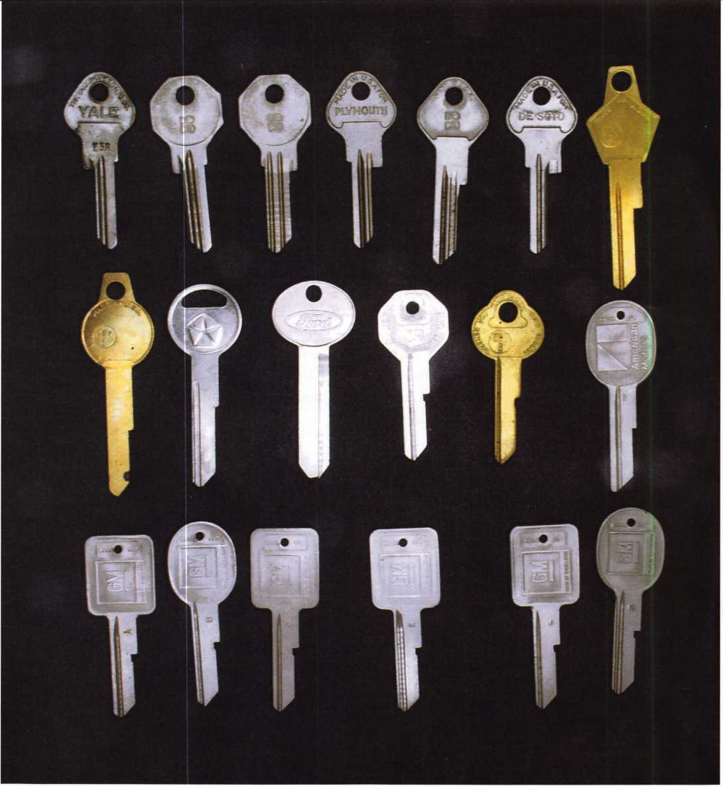

A Brief (and Interesting)  
History of Automotive Keys

By Merritt Perkins, RL

Keynotes • January 2004

Before we discuss automobile  
keys, we need to know a

little about the auto-

mobiles and  
their history  
More than 15  
and a half mil-  
lion Model T

Fords were manufactured in  
the United States from 1908 to 1927 -- more than all  
other makes of automobiles. In 1914, a completed  
chassis was assembled every 93 minutes; in 1927,  
every 24 seconds.

Ford owned iron mines in Minnesota and Michigan and ore carrier ships to bring the ore to River Rouge. He owned coal mines in Kentucky and railroads to bring it to River Rouge where the assembly lines were. I recall watching glowing hot coke pushed from a fur­nace fall into a railroad boxcar at the River Rouge plant where it was used to make steel.

The Model T Ford was very different from other automobiles. Cars of that time were touring cars with a front and back seat and open top. A fabric top was attached to a frame that folded it up and stored it behind the back seat. When unfolded, it attached to the top of the windshield. There were side curtains that could be attached to enclose the sides.

There was also a single seat model called a “runabout.”

There was no door on the driver’s side. A brake lever to the left of the driver set the brakes on the two rear wheels when pulled back and also depressed the clutch pedal halfway to the neutral position. There were three pedals, a brake on the left, reverse in the center, and the clutch on the right. When the clutch was pushed down it was in low gear, and when all the way up, in high gear. The pedals tightened fabric-lined bands to grip the three drums of the planetary trans­mission, and the tension on the bands could be adjust­ed to compensate for wear.

There were two levers behind the steering wheel. The left lever adjusted the timing of the spark. Up it was retarded, as when starting, and down it was advanced. The right lever (the gas lever) adducted the throttle to control engine speed.

The engine was started with a hand crank in front of the radiator. Often a wire was attached to the choke on the carburetor and extended through the radiator so that you could choke the engine while cranking it. Around 1920, a six-volt starter and generator were installed using a six-volt storage battery The starter had a Bendix drive that engaged a ring gear on the fly­wheel. At this time, the ignition switch was moved to the dash and had a key lock with 24 changes, F51 to F74. The switch had three positions: Magneto, Off and Battery Beside the switch was an ammeter to show the battery charge or discharge.

The magneto consisted of a group of V-shaped perma­nent magnets attached to the front of the flywheel that moved past stationary coils. The ignition system consisted of four induction coils in a coil box under the dash. The high tension terminal of each one attached to a spark plug. One primary terminal con­nected to the switch and the other to the timer, which had four insulated terminals that a wiper on the end of the cam shaft made contact with, in sequence. The spark lever rotated the timer to adjust the timing. The vibrating armature on the induction coils would give a sequence of sparks, and you could hear them buzzing.

Sometimes, young fellow would connect up a spark coil, so that when anyone touched the car while it was turned on he would get an electrical shock. The gaso­line tank was under the front seat. To see how much gasoline was in the tank, you used a stick similar to a ruler to dip into the tank. There was a tool box on the running board which might contain a monkey wrench, slip joint pliers (furnished by Ford), tire pump, repair kit for inner tubes and tires, and other tools.

The 1915 Dodge touring car had a 12-volt electrical system with a starter-generator connected to the

Keynotes • January 2004

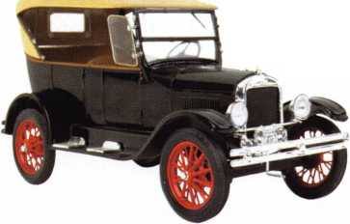

motor with a silent chain drive. The four-cylinder engine had a priming cup on each cylinder. The igni­tion system had a single ignition coil with cam-actuat­ed breaker points in the primary circuit, and a distrib­utor to connect the high tension terminal to each sparkplug in sequence. The ignition switch was mounted on the dash and had a stamped steel key with 24 combinations, DB76 to DB99.

introduced the Model A, which was discontinued in 1931, followed briefly by the Model B. In 1932, Ford introduced the V8, with an ignition lock that also locked the steering column. This had a little pin tum­bler key with no grooves on the sides, the top being narrower than the bottom.

The spacing of the cuts was .170 inches from shoulder to center of the first cut, .125 inches between cuts.

^ Sometimes, young fellow would connect up a spark coil, so^ that when anyone touched the car while it was turned on he ^ would get an electrical shock.

The gasoline tank was mounted in the back, and a vacuum tank mounted on the bulkhead in the engine compartment was connected to the intake manifold and supplied gasoline to the carburetor. The gear shift was floor-mounted and the transmission worked like those in many later cars.

Dodge Brothers was incorporated in 1914 and was purchased by Chrysler in 1928. In 1922, Walter P. Chrysler took over both Willys-Overland and the Maxwell Motor Car Co., which was founded in 1904 and had taken over the Chalmers Motor Car Co. when it failed in 1908. In 1925, it became Chrysler.

Three years later, after the purchase of Dodge Brothers, Chrysler introduced the Plymouth to com­pete with Chevrolet and Ford. In 1933 and 1934, the Chrysler cars, Chrysler, Dodge, DeSoto and Plymouth used a bent or offset key (with locks made by Yale). The keys for the different makes differed in the length of the shoulders of the blade. These keys were difficult to cut, and the demand for them soon disappeared.

In 1935 and 1936, straight keys were used with differ­ent grooves for each Chrysler model. In 1927, Ford shut down his plants to retool, and in December 1927,

The depths were .195, .175, 155, .135 and .115 inches. Around 1950, the locks had no shoulder in front, and a shim could easily be introduced from the front to pick and shim it open. Bargman also used similar locks for mobile or motor homes.

Breakaway pins were made for these locks. The lower and driver pins were made in one piece nearly cut in two, so that the pins could be assembled in the lock and the key inserted and turned to break the two pieces apart. This left a tiny tip where it broke apart that dug into the die cast plug and cylinder.

Later, Ford used a single-sided key with a groove down the side and spacing of .199 inch from shoulder to center of first cut and .125 inch between centers of cuts. The depths were .240, .220, .200, .180 and .160 inches. Next, they used a reversible double-sided key with the primary and secondary key with opposite milling, so that they would not enter each other’s keyways. The pin tumblers were only on one side of the lock.

In the late 1920s, Studebaker and Erskine (made by Studebaker) had a lock on their steering column that locked the steering and ignition. In 1954, Studebaker merged with Packard. In 1963, they announced new

**8**

Keynotes • January 2004

keys and locks, but ceased U.S. production in 1963  
before any were used. They ceased production in  
Canada in 1966.

In 1932, Chevrolet used a small key, and in 1933, Buick  
and Oldsmobile used different grooves. In 1934,  
General Motors used a double-bitted key with three  
cuts on each side. There were three different grooves  
for the center part for different models: 1934 Nash  
and 1934 Chevrolet; 1934 Cadillac, 1934 LaSalle and  
1934 Oldsmobile; 1934 Buick and 1934 Pontiac.

In 1935, General Motors went to the sidebar lock with  
six tumblers that had the same keyway grooves for  
both the primary key (which had an octagon head for  
ignition and door) and for the secondary glove-and-  
trunk key (with a pear shaped head). Both keys had a

small hole in the knockout  
insert on which the code num-  
bers could be stamped. Some  
tried to drill the hole out larg-  
er instead of knocking out the  
insert. The spacing of the bit-  
ting cuts was .107 inches from  
the shoulder to the center of  
the first cut and .093 inches  
between cuts. The depths  
were .250, .225, .200 and  
.175 inches.

A set of 64 tryout keys was  
available with cuts half way  
between the correct bitting

depths to unlock these locks. The keys were inserted  
in these locks with the notches or bitting cuts down  
instead of up as in most pin and disk tumbler locks.

To open a lock when the key was missing, the cap was torn or cut off with side cutting pliers, a small hole drilled at the left side so that a tool such as a wire with a beveled end could be inserted to put pressure on the side bar, and raise the tumblers so that the side bar would enter the notch in the H shaped tumbler.

The tumbler springs were quite strong, and the  
side bar springs very light, so that the tumbler would  
lift the side bar out of the notch in the tumbler.

When the side bar extended from the plug into a slot  
in the lock case, it prevented the plug from turning.  
When it was flush with the surface, the plug could  
be turned.

After many years, until about 1970, the same basic  
design was still used, but new keyway grooves desig-  
nated by the letters A, B, C, D, E, H, J, and K  
stamped on the key and keys with a rectangular head  
for the primary or ignition key and an oval head for  
the secondary key that operated the doors, glove and  
trunk. There were still inserts for the code number to  
be knocked out. The keyways and codes were changed

each year.

The spacing was changed to .109  
inches from shoulder to center  
of first cut and .093 between  
cuts. The depths were changed  
to .248, .223, .198, .173 and  
.148 inches.

Chrysler used small Yale spacing  
of .146 inches from shoulder to  
center of first cut and .140 inch-  
es between centers of cuts. In  
1971, they kept the same key  
blanks as the previous year, but  
changed from five biting depths  
of .255, .230, .205. .180 and .155

inches with increments of .025 inches to six depths  
with increments of .20 inches, .247, .227, .207, .187,

.167, and .147. New codes were published for the increased number of combinations.

Since then, automotive keys have seen many more changes. But as in any area of professional specializa­tion, an awareness of the general history of these locks is helpful. Not to mention interesting.

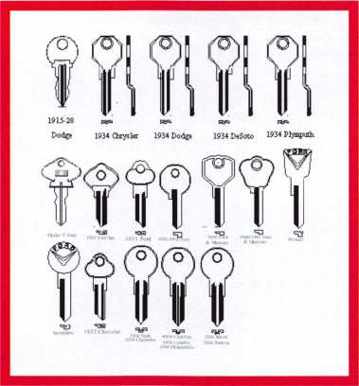

Keynotes • January 2004

Helping Out on a Re-Hanging

By Greg Perry, CML, CPS

**20**

Keynotes • January 2004

t

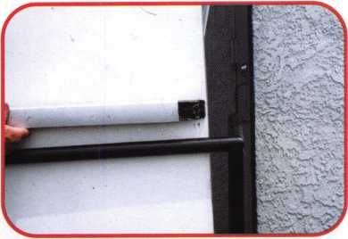

Old Adams Rite exit device. The black rail is not attached to the door.

Last year, we looked at re-hanging a pair of alu­minum glass doors. This year, it’s time to re­hang a hollow metal door. Although we used the same type of hinge and fasteners, the method of installation is different. This job came about because of proper salesmanship by another locksmith. His request for service was to repair the broken door alarm. When he looked at the door and frame, he recommend­ed repairing the whole opening. I use the term “proper salesmanship,” because he recom­mended what was appropriate not because it would make him more money, but because it was needed for a reasonable amount of securi­ty. Since he is a one-man shop, he requested that I give him a hand with the repairs. This job could be done alone, but it would take longer, and during some parts of the job, it would pose some safety issues.

2

The latch edge at the top of the door is badly worn.

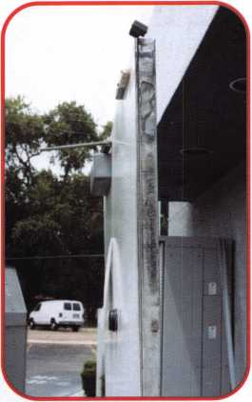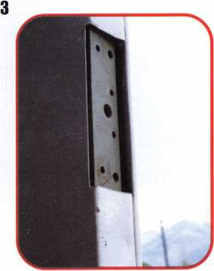

The hinge mount in the door is bent and no longer properly supports the door.

Keynotes • January 2004

4

5

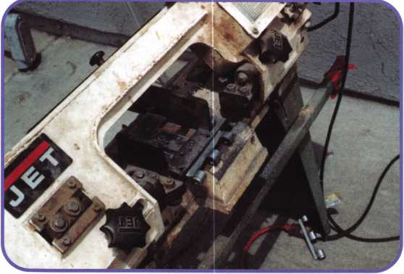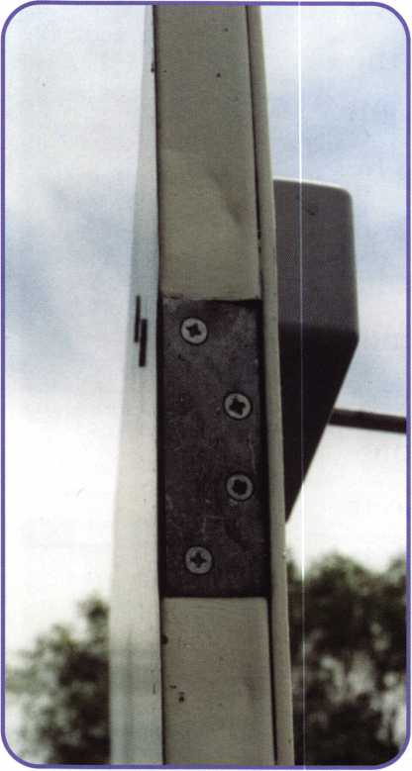

The hinge plates are now reinstalled as filler plates.

We started with an opening in need of a lot of  
help. The existing exit device was beat up from  
years of use on the back door of a fast food  
restaurant. The hinges were badly worn. The  
hinge mounting plates in both the frame and  
door were bent, and the welds would not sup-  
port realignment. The upper three feet of the  
door latch edge was rubbing, and the door alarm

We are using a band saw to cut off the hinge knuckles. didn’t operate. Three things were still usable.

The frame was secured to the wall, the door was  
still intact internally, and the closer was only a few years old.  
It was definitely time for a re-hanging.

The first thing we did was to disconnect the closer arm and  
remove the hinge pins. Next, we removed the door from the  
opening and set it aside. The hinge leaves were marked on  
the backside to match the edge of the frame and the face of

the door. Next, we set

up the band saw to start  
cutting the old hinges

while we worked on  
mounting the new  
hinge. Once the hinge  
knuckles are cut off,  
they become filler  
plates. Last year, I chose  
Select SL21 full surface  
swing clear hinges.  
Those doors were  
three-footers, and the  
additional opening  
width gained with a  
swing clear hinge was  
nice. This time I choose  
a Select model SL57 full  
surface hinge. The door  
is four feet wide, so the  
additional opening  
width is not needed. In  
addition, the swing clear

The hinge leaf frame side is installed in the first.

Keynotes • January 2004

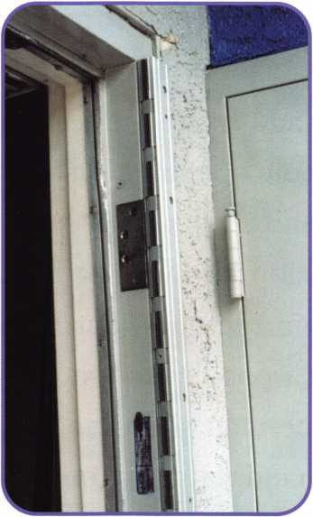

model requires 11/2-inch of clear frame face. The SL57  
full surface requires only 7/8-inch clear surface on the  
frame. The stucco on the wall partially covers the  
frame. The SL57 full surface is the best choice for  
this application.

The frame leaf is attached first. Next, the old (now  
cut) hinge leaves are replaced. Wood shims typically  
used behind the frame (or wood shingles) are used to  
position the door. They are placed on the threshold,  
and the door is placed on the shims. Next, we shim  
the door in the opening side to side to leave about a  
1/8-inch gap on the latch side. Once the door looks  
good in the opening, move the hinge over the door

and install the self-drilling screws in the  
smaller holes. Remove the shims and  
carefully open the door. Now is the time 3  
to test the door for fit and function. Is  
anything binding, and is the gap around  
the door correct? If everything looks  
good, then drill a couple of the 3/8-inch  
holes through the hinge and door. Next,  
install the through-bolts and screws in  
those holes. Check the door fit one more  
time before drilling the balance of the  
holes and installing the through-bolts  
and screws. We add several pop-rivets  
between the screws; this adds a degree of  
tamper resistance and additional  
strength. Once all the fasteners are  
installed and the fit checked, the covers  
are installed.

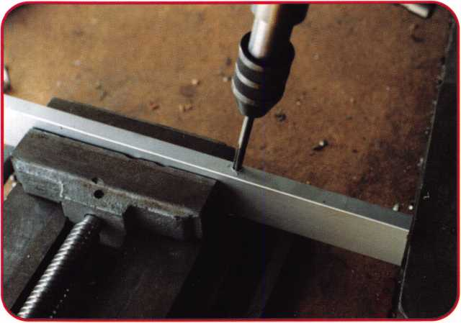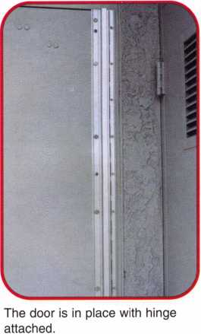

The door closer arm was reinstalled and  
an Alarm Lock 70R exit alarm panic device  
was installed. Finally on this job, we  
checked the weather-stripping to make 9  
sure it still provided a good seal. Time to  
write an invoice.

We don’t have to be great salespeople, but  
we should be proper salespeople. Several  
high-traffic businesses are now specifying  
these hinges for original installations.  
They’ve learned the value of spending a  
few extra dollars up front to save it in  
reduced maintenance costs later. This  
type of job can be very profitable and pro-  
vide your customer with a high quality  
installation -- a win-win situation.

Because we cut the hinge, the bottom cover screw needed to be moved. I used a drill press ot drill the hole; then I tapped it to 8/32 thread.

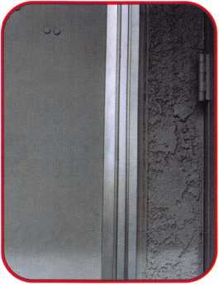

The covers are installed.

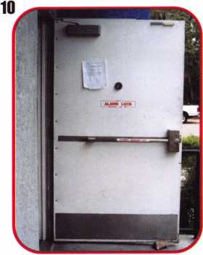

The inside view with new alarm lock 70R, installed.

Keynotes • January 2004

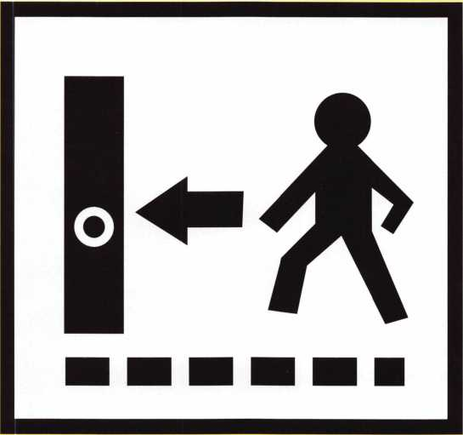

Going in the Side Door

By Greg Perry, CML, CPS

Keynotes • January 2004

This month, well look at a pair of Overly vault doors. On the pair we were servicing locally, the main entrance would not open. The cus­tomer had the combo to the Mas Hamilton X-07 lock, but the handle would not turn far enough to retract the bolts. I tried the handle; sure enough, it would not turn, and the lock bolt was retracted, but the door still would not open. I could tell the lock bolt was retracting because of the amount of travel after the step­per motor fired inside the lock. There is no relock inside the door, so what could be keeping the door locked? What could be the problem? The customer mentioned a side door, but they had no idea who had the combination, or even when the door was last opened. This door had a Sargent & Greenleaf 8560 series lock. The only problem here is a lost or forgotten combination. Opening either door gives us access to the inside of the other. Which door would you want to open? I chose the second door (as seen in photo 1).

I started by removing the dial. Using a pair of vise grips on the knob, I wiggled the dial up and down until it broke off, about even with the dial bushing. Next, I removed the dial ring and attached a StrongArm MiniRig template to drill a scope hole. The building was erected about 1990, so the door was built prior to the GSA requirement for carbide included hardplate, yet the hardplate destroyed a couple of carbide bits before I switched to a diamond-core drill. Once inside the lock case, I scoped the wheel pack, setting the wheel gates under the fence, and opened the lock. Once inside the building, it was time to open the other door.

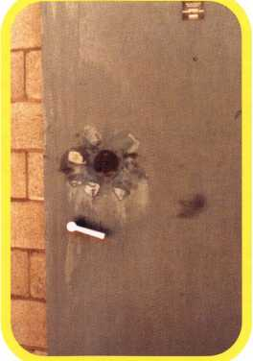

Photo 1

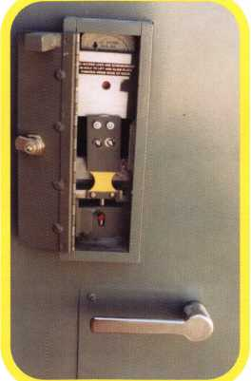

Photo 2

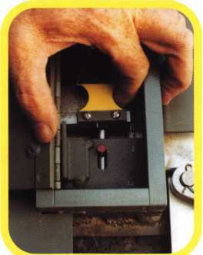

Photo 3

Opening the door from the inside is much easier than from the outside. First, you need the key for the lock cover. In most cases, it’s attached to an eyebolt in the upper hinge side corner on the inside face of the door. Opening the lock cover reveals a red pin attached to a spring-loaded bolt. This can be seen in photo 2. Push down on this pin; pull out on the lock bolt extension seen in the pho­tos 3 and 4, then turn the inside han­dle to retract the door bolts. The door will now swing open. Under normal operation, the lock retracts the bolt extension. This moves the extension away from the spring- loaded bolt. Photo 5 shows the ramp area of the door bolt track. The bolt extension is pushed toward the back of the door as the handle is turned to retract the door bolts. Opening the cover on the door that wouldn’t open revealed the red pin sitting at the bottom of the lock box. The problem was the spring-loaded bolt was pushed up into the lock bolt extension, even with the lock bolt retracted. It was a simple matter of using a probe to pry the spring- loaded bolt down and open the door.

I’ve thought about the prospect of opening this door if we didn’t have the other door go through. The only viable method I’ve found would be to drill for the bolt and pry it down from the outside. This would require drilling at 6.5 inches down from the dial center about 2.75 inches deep. The problem with this location is that the GSA does not allow drilling outside of the dial ring.

The hole in the drilled door was repaired with a carbide plug welded in both sides. Next, the area under the dial ring on the door was puttied, textured and painted. A new X-08

Keynotes • January 2004

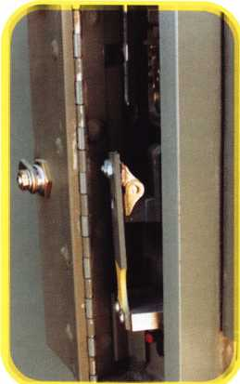

Photo 4

was installed on the door, which required drilling and tapping the end of the lock bolt to accept the bolt extension. The other door required reinstalla­tion of the red pin. Before installing it, I put a dab of red Locktite on the threads.

This is not the first time I’ve gone around a prob­lem. Oftentimes, there are multiple ways to get in. Bank vault walls are core drilled to avoid drilling the vault door; I’ve knocked a hole in a wall to avoid damaging a $5,000 sound-rated door. Always look for the easiest method, providing it is professional, and does not cause more damage or additional expense.

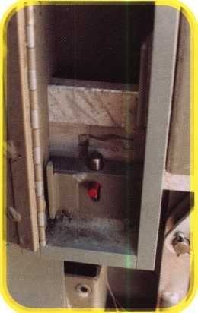

Photo 5

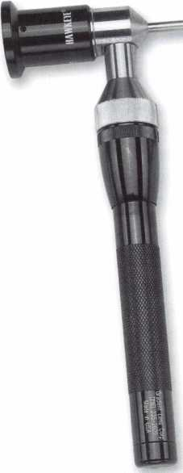

item Year.New Specials.

Hawkeye™ Precision Borescope

All probes are the slim line - only 4.2mm in diameter. All kits have a built -in adjustablefocusing eye­piece to allow for wider range of visual distances. A 40° field-of-view is achieved with the straight view probe and the 90° probe. Includes a 7" Probe, Mirror Tube, Power Handle and hard lockable case.

Special offer - order now while quantities last.

IKM1202CS Regular $745.00 SALE PRICE $499

Navigator 10 Piece Pick Set

Contains 15 of the most popular pick blade instruments and 4 specially designed tension tools . Belt case included

LKM217 PRICE $39.00

Lockmasters Pick Gun

(JCP+Jew Pick Gun has a very strong spring that will efffff pick pin and disc tumbler locks. Improvements include screws instead of rivet construction for easy **repaiFsrnd** a larger bolt for changing blades. Includes 3 blades & 1 tension wrench.

mim

set

IKM225 PRICE $36.99

Contains 7 of the most popular pick blade instruments and 2 tension tools (including 1 two*finger tension wrench). Belt case included

LKIVI230 Reg. $16.50 SALE $10.00

**IQCKMflSTERS**

INCORPORATED

lockmasters.com 800.654.0637 Call For A 2004 Vol. 1 Tool Catalog

Mark Your Calendars...0ur 2004 Parts Catalog Will Be Available In March 2004.



Keynotes • January 2004

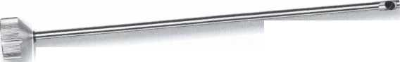

Proue You’re a Pro ’04

HLOH Rewards Its Members HGRINM

The RLOR Membership Campaign for 2004 features

more member benefits than we’ue euer offered

before. LUe’re stuffing members full of great gifts!!

If you renew your commitment to your industry  
and help support RLOR, uie will offer FREE mem-  
bership dues to ANY CURRENT MEMBER who  
recruits one new member on or before January  
1, 2004.

RLOR is excited about the uast legislatiue challenges that lie ahead,

and we re waiting for our members to let us after those groups that  
are aiming to legislate locksmiths out of business, one bad bill at a

time. Were readg to do our part for the prosperitg of this industrg.

Please help gourselues bg doing gour part this gear. Proue you’re a pro bg

sticking with HLOH in 2004. Vou will be rewarded for it mang times ouer.

Note: The HLOH Board of Directors has enacted a $25 Legislatiue assessment to the regular HLOH dues for all actiue members in the USH (and territories) in 2004. If gou liue in the United States or its territories, gou must pag the assessment to maintain gour membership. The assessment will be pagable during this gear s dues billing, which mailed on Oct. 1, 2003. Hs directed specificallg in writing bg the HLOH Board, the proceeds from this assessment will be auailable for use ONLV in BLOB's legislatiue efforts.

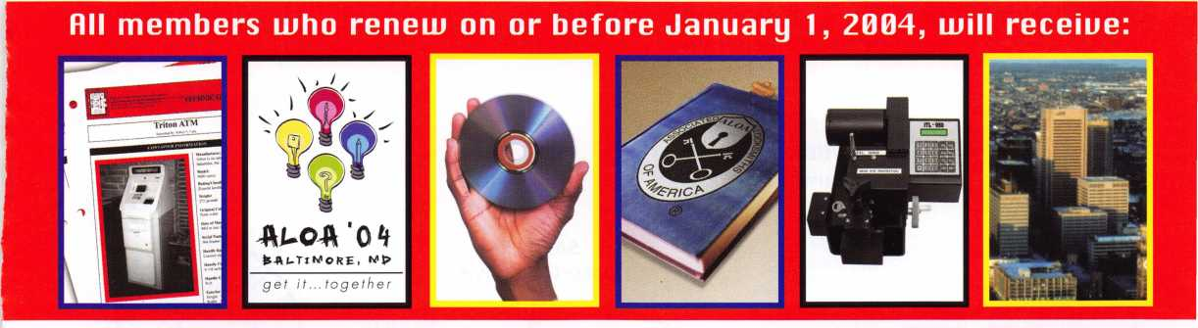

H complimentary set  
of 2 safe technical  
bulletins

Up to $300 sauings  
on RLO0 2004  
Conuention  
registration

R complimentary  
copy of the RLOR  
Membership  
Directory (CD)

R $10 discount for any purchase from the RLOR Bookstore

Rutomatic entry into  
a drawing for a  
brand new ITL-950C  
key code machine



Associated Locksmiths of America

3003 Liue Oak Street • Dallas, Texas 75204-6186

800-532-ALOA (2562) • **wiULU.aloa.org**

Rutomatic entry into  
a drawing for a free  
RLOR 2004  
Conuention Full  
Registration  
Package (including  
hotel)



This Ain’t %ur Daddy’s Locksmith Business!

By Tom Seroogy

Every now and then, I enjoy reading those little e- mails letting you know how old you really are. We’re familiar with most - “When you were born a car cost $1,500; a Harvard education - $2,500; paper plates were made of paper; 8-Track tapes ruled; and two hamburgers, fries and a Coke cost a dollar...”

Well, as I set out to write this article, it dawned on me the dramatic changes that have occurred through­out the evolution of automotive security. On my father’s car, security was the lock and key; just enough to keep the honest people honest. Security during my time includes the introduction of high security lock­ing systems and electronic disabling systems like VATS. Although keys were still widely used, my son and daughters’ made their driving debut around the time of GM’s Passlock system, and the birth of transponder technology, during what is probably the fledgling era of electronic automotive security.

As for my grandchildren - yes, I have three - by the time they learn to drive, a museum (or grandpa’s garage) may be the only place to see a car key. Vehicle security will be fully electrically based - infrared, transponders, biometrics - truly the age of Star Trek. Or, maybe, Star Wars - or, maybe... In other words,

the automotive locksmith of tomorrow will be very much different from the automotive locksmith of even today, let alone yesterday.

Still, the proliferation of electronic technology in automobiles has affected more than the locksmith - namely, the automotive techician. In fact, the nearly nonstop assault of technological and legislative revi­sions has affected the day-to-day operation of the automotive trade more than any other. Moving in stride with the fledging electronic security revolution are the growing concerns and demands of the EPA. With the single goal of creating standards for cleaner emissions, the EPA introduced OBD I/I I in efforts to bring all vehicles manufactured in the United States under a uniform diagnostic umbrella. Although the OBD II standard went into affect in 1995, it wouldn’t be until 1996 that OBD II and the introduction of transponder-based immobilizers would begin to effect the amalgamation of the automotive technician and the locksmith. To date, ongoing additions to EPA requirements, the advancement of high-tech/low-cost electronics, and the need for greater security, are changing the face of the automotive locksmith. The future, for those who grasp and hold on for the jour-

Module

Programming

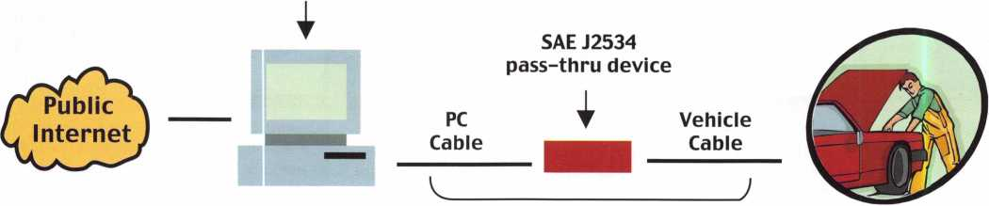

1. With a single Pass-Through diagnostic tool and connected to the internet, the locksmith may one day be able to program keys for any car on the road.

**28**

Keynotes • January 2004

ney, will witness the locksmith metamorphosed from a key-cutter to a highly educated technician. (See sidebar on Lockmasters PUREAuto certification.) And, as always, those that comprehend and seize the opportuni­ties presented by this rapidly-changing industry are those most likely to reap the first and principal share of the benefits.

History of the Tools

So, with all of the changes and uncertainty in today’s market, where does a locksmith start? Well, let’s begin by looking at the evolution of the tools that have been available to the automotive locksmith. In short, these tools can be divided into three types, offered at three different time frames:

1. Original Equipment Manufacturer (OE or OEM) - 1996 to present
2. Aftermarket - 2000 to present
3. Pass-Thru - 2003 and above.

OEM - 1996 to current

For the most part, the locksmith’s exposure to diagnostic tools was limited until the introduction of transponder- equipped vehicles in 1996. Fortunately, for most early model transponder-equipped vehicles, key programming could be accomplished using onboard programming pro­cedures - including GM and Ford vehicles.

Unfortunately, except for GM, late model year changes required the use of an original equipment diagnostic tool to complete key programming. Initially, because these tools were not sold to the open market, they were extremely expensive, or otherwise hard to come by.

Many could only be obtained by making purchases via connections within the automotive industry.

Soon, however, a couple of manufacturers began to see the merit in offering their diagnostic tools into the after- market. By far, the most common tool is Ford’s NGS, manufactured by Hickok Inc. Ford was the only manu­facturer to offer a complete OE diagnostic tool into the aftermarket, including the ability to access the key pro­gramming functions, as well as a full compliment of tech­nical support through Hickok Inc. Chrysler also offered their DART tool, but lacked depth by not including the technical support offered by Hickok.

2003/2004 CAN Equipped Vehicles

|  |  |  |  |
| --- | --- | --- | --- |
| YEAR | MFG | MODEL | ENGINE |
| 2003 | Ford | Excursion | 6.0 |
| 2003 | Ford | F-250 | 6.0 |
| 2003 | Ford | F-350 | 6.0 |
| 2003 | Ford | Focus | 2.3 |
| 2003 | Ford | Focus | 2.3 |
| 2003 | Ford | Thunderbird | 3.9 |
| 2003 | Lincoln | LS | 3.0 |
| 2003 | Lincoln | LS | 3.9 |
| 2003 | Mazda |  | 6 2.3 |
| 2003 | Mazda |  | 6 3.0 |
| 2003 | Porsche | Cayenne | S 4.5 |
| 2003 | Porsche | Cayenne Turbo | 4.5 |
| 2003 | SAAB | 9-3 | 2.0 |
| 2003 | Saturn | ION | 2.2 |
| 2004 | Buick | Rendezvous | 3.6 |
| 2004 | Cadillac | CTS | 3.6 |
| 2004 | Cadillac | SRX | 3.6 |
| 2004 | Cadillacs | RX | 4.6 |
| 2004 | Cadillac | XLR | 4.6 |
| 2004 | Dodge | Durango | 3.7 |
| 2004 | Dodge | Durango | 4.7 |
| 2004 | Dodge | Durango | 5.7 |
| 2004 | Ford | E-250 | 6.0 |
| 2004 | Ford | E-350 | 6.0 |
| 2004 | Ford | Excursion | 6.0 |
| 2004 | Ford | Explorer | 4.0 |
| 2004 | Ford | Explorer | 4.6 |
| 2004 | Ford | F-150 | 4.6 |
| 2004 | Ford | F-150 | 5.4 |
| 2004 | Ford | F-250 | 6.0 |
| 2004 | Ford | F-350 | 6.0 |
| 2004 | Ford | Focus | 2.3 |
| 2004 | Ford | Focus | 2.3 |
| 2004 | Ford | Taurus | 3.0 |
| 2004 | Ford | Taurus | 3.0 |
| 2004 | Ford | Thunderbird | 3.9 |
| 2004 | Lexus | LS430 | 4.3 |
| 2004 | Lincoln | LS | 3.0 |
| 2004 | Lincoln | LS. | 3.9 |
| 2004 | Mazda |  | 3 2.0 |
| 2004 | Mazda |  | 3 2.3 |
| 2004 | Mazda. |  | 6 2.3 |
| 2004 | Mazda |  | 6 3.0 |
| 2004 | Mazda |  | 6 2.3 |
| 2004 | Mazda |  | 6 3.0 |
| 2004 | Mazda | RX-8 | 1.3 |
| 2004 | Mercury | Sable | 3.0 |
| 2004 | Mercury | Sable | 3.0 |
| 2004 | SAAB | 9-3 | 2.0 |
| 2004 | Saturn | ION | 2.2 |
| 2004 | Toyota | Prius | 1.5 |
| 2004 | Volvo | S40 | 2.4 |
| 2004 | Volvo | S40 | 2.5 |

Other tools were available, but more expensive and harder to come by. Included in this group are the Nissan/Infiniti Consult II and Mitsubishi’s MUTII. The advantages of purchasing OEM diagnostic tools were threefold: First, they offered the locksmith the ability to program keys into the latest transponder- equipped vehicles. Second, because the tool is an OEM tool - providing that the correct key is used and the software is kept up to date - there were few programming problems. Finally, for problem vehicles, the OE tool allowed the locksmith to perform system diagnostics, including retrieve, correct and clear Diagnostic Trouble Codes. Needless to say, the lock­smiths who first took advantage of these tools reaped the greatest benefits.

As with every advantage, however, there were several drawbacks to purchasing the OEM tool. The first hurdle has been that OEM tools are not only expen­sive, but they are manufacturer specific. As such, a different machine would have to be purchased for each line of cars a locksmith wanted to service. Needless to say, the full compliment of diagnostic tools would cost the locksmith upwards of $15,000. Also, initially, factory support was nonexistent and software updates almost impossible to obtain. Again, Ford and Chrysler’s forward thinking allowed access to both technical support and software updates through legitimate channels. Other machines, like the Consult II and the MUT II, were left to the devices of the locksmith for obtaining support and updates.

A final problem with owning the OEM tool is that, as of 2004, machines being made for the newer CAN systems as well as the SAE J2534 requirements and specifications, are quickly replacing the older OEM machines. We’ll take a look at this when we cover Pass-Thru technology later in this article. (See table insert for a list of CAN equipped vehicles.)

Aftermarket - 2000 to current

Unfortunately, the investment required for program­ming all of the manufacturer vehicles, plus the diffi­culty in obtaining software updates and PIN numbers

put transponder work outside the reach of many qual­ified locksmiths. With locksmiths desperately search­ing for a way to perform the automotive key genera­tion service they’ve been providing for years, the need for a single, multi-vehicle transponder programmer was apparent. The first attempt at filling this vacuum was the late 2001 introduction of ASP’s TCL-i. Although coming up somewhat short on the perform­ance end, the tool offered the locksmith a glimmer of hope for doing automotive work again. On the heels of the TCL-i, Ilco introduced the SDD (Silca’s Diagnostic Device). Developed by Silca and sold into the United States by Ilco, the SDD has a proven track record in the European transponder market. Working with auto lock expert Randy Mize, Ilco developed the software necessary for using the SDD in the North American auto market. To date, the SDD has proven to be a versatile and well-made machine, backed by one of the world’s largest providers of OEM and aftermarket transponder key blanks.

Still, ASP’s drive to help the locksmith maintain their presence in the automotive market did not stop here. In late 2002, the TCL-i was replaced by the better performing and more robust T-Code. Manufactured by Advanced Diagnostics, and sold in Europe as the AD-100, the T-Code was fitted with software for the North American vehicle market and has proven a great successor to the TCL-i. A latecomer to the transponder tool line is STRATTEC. Although STRATTEC has been instrumental in the design and supply of OEM and aftermarket transponder keys since 1996, it is not until early 2004 that they are expected to release their North American version of Advanced Diagnostics’ AD-100, calling it the “Code- Seeker.” Based on the performance of other Advanced Diagnostic tools, the Code-Seeker is likely to meet all of the expectations of the automotive locksmith.

All in all, the locksmith wishing to enter and/or main­tain automotive key generation work has several cost- effective options from which to choose. To date, all released tools have proved out well, with few bugs, and some extra features to boot. Which one should

**30**

Keynotes • January 2004

you choose? Let’s just put it this way: I’ve found that for every tool, there to two types of locksmiths - those that swear by it, and those that swear at it.

The benefit of owning an aftermarket transponder tool is self-evident - one-time investment for doing work on cars from various manufacturers, over and over again. The downside to an aftermarket tool, however, needs to be considered. First, unlike the OEM tools, the software for the aftermarket tool must be backward engineered. As such, the release of software updates not only lags behind the release of the new vehicles, but may also include bugs, or the inability to do specific vehicles at all. Also, unlike OEM tools, aftermarket tools are limited in their diag­nostic capability And, in an aging transponder market, this single feature can sometimes prove invaluable.

J2534 Pass-Thru - 2004 and into the future!

Going into 2004 and beyond will yield some dramatic changes to the automotive aftermarket. These changes affect anyone doing automotive work - mechanics, body shops, locksmiths, police, investigators, insurance com­panies, parts stores, etc. The chief reason for these changes are the rules and provisions of the EPA’s SAE J2534 requirements. The documentation for the final rule is extremely involved, and is beyond the scope of this article. However, we do want to cover those few aspects that affect the locksmith. If you wish further informa­tion, the entire document, available at the Federal Register, can be downloaded as a PDF file from <http://a257.g.akamaitech.net/7/257/2422/i4mar20oio8oo/e> d0cket.access.gp0.g0v/2003/pdf/03-14461.pdf.

In short, the two features of this rule that may have dra­matic effects on the business of the automotive lock­smith, are web access to all OBD-related information and the new upcoming Pass-Thru tool technology. Although these two features are designed to work jointly, let’s cover each separately.

Regarding web access, the EPA has required that all manufacturers of motor vehicles provide all OBD-related information to the aftermarket via web sites. The infor­mation is to be exactly the same as that provided to the



Acura - <http://www.ServiceExpress.Honda.com> Audi - <http://erwin.audi.de> BMW - <http://www.bmwtechinfo.com> Chrysler/Dodge/Eagle/Jeep/Plymouth -<http://www.techauthority.com> Ford/Lincoln/Mercury -

<http://www.motorcraft.com> General Motors (includes Buick/Cadillac/Chevrolet/ Geo/GMC/Hummer/Oldsmobile/Pontiac/Sat urn) - <http://www.gmtechinfo.com> Honda - <http://www.ServiceExpress.Honda.com> Hyundai - <http://www.hmaservice.com> Infiniti - <http://www.infinititechinfo.com> Isuzu - <http://www.isuzutechinfo.com> Jaguar - <http://www.jaguartechinfo.com> Kia - <http://www.kiatechinfo.com> Land Rover - <http://www.landrovertechinfo.com> Lexus - <http://techinfo.lexus.com> Mazda - <http://www.mazdatechinfo.com> Mercedes Benz - <http://www.startekinfo.com> Mini - <http://www.minitechinfo.com> Mitsubishi - <http://www.mitsubishitechinfo.com> Nissan - <http://www.nissantechinfo.com> Porsche - <http://techinfo.porsche.com> Saab - <http://www.saabtechinfo.com> Subaru - <http://www.subaru.com> Suzuki - <http://www.suzukitechinfo.com> Toyota - <http://techinfo.toyota.com> Volkswagen - <http://www.erwin.vw.com> Volvo - <http://www.volvotechinfo.com>

Keynotes • January 2004

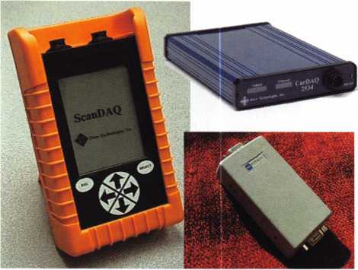

2. It’s now open game for diagnostic tool manufacturers to make a single machine that covers all manufacturers.

OEM dealers. The benefit of this  
media is our ability to instantly  
access the information at any  
time. As the deadline for web  
site delivery of the vehicle manu-  
als is now past, locksmiths doing  
automotive work have the ability

to tie into these various sites, as needed. (See OEM  
Web Sites in list four.)

There are a couple of shortcomings to the web access, however. First, and probably the most important, the final rule on SAE J2534 does allow OEMs some lati­tude with the requirements on releasing security- related information - i.e. key codes, pin numbers, etc. In fact, the rule has made provisions that currently allow the OEM to protect this information from release. Still, a few manufacturers are offering parts of this information through web access. Mazda states that they will offer the PIN number, needed for key programming, to site subscribers. A few locksmiths have tested accessing PINs -- with little success. However, there is hope. Ford, on the other hand, has made their immobilizer information available through their web site, and more importantly, directly through their Pass-Thru module program site.

Albeit rather minor, a second disadvantage to web access is simply the expense of accessing the site.

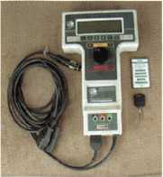

Needless to say, if you want the info - “you’re gonna havta pay for it” - every time you need it! Probably the most convenient for locksmith purposes is the single day subscription. For around $20, a technician has access to the dealer site for a 24-hour period.

For the most part, the cost of the subscription can be built into the price of the job, and if doing more than one job, you can make the subscription pay for itself. All manufacturer sites offer various subscrip­tion levels. For a review on the subscription rates of manufacturer tech web access, go to the National Automotive Task Force web site at [www.nastf.org](http://www.nastf.org).

Now for Pass-Thru programming. Depending on which way the market turns with respect to providing security information (namely PIN numbers), and depending on the locksmith’s ability to take advantage of this new technology, Pass-Thru technology could be a boom to the automotive locksmith market. At the heart of the Pass-Thru issue is an EPA requirement for all vehicles manufactured after 2004 to be able to be programmed by a single Pass-Thru diagnostic tool! Of course, in order for a single tool to operate all manufacturer vehicles, a few things must be put into place. To accomplish this, a standard has been created that establishes a mode(s) of communication with the vehicle’s OBD-related modules that all manufacturers must meet. With this standard, any aftermarket diag­nostic tool manufacturer is capable of building a sin­gle tool for covering the entire car market. The biggest challenge, of course, is how does a single tool handle the software for all the years of all the models of all the manufacturers that are currently available? What about past and future models? What about mid-year and year-end engineering changes? What about software upgrade availability?

Providing a solution to these questions is the concept behind Pass-Thru programming. In short, all software for vehicle programming is provided directly from the manufacturer via a CD or directly through their des­ignated web sites. A technician wishing to work on a

Keynotes • January 2004

vehicle first purchases the manufacturer’s software CD, or subscribes to the manufacturer’s web site.

Once connected, one end of the Pass-Thru tool is connected to the computer using standard computer connections; the other end of the tool is connected to the vehicle using the standard OBD II compliant data link connector, or DLC. At this point, the vehicle is now ready for programming!

The benefit to the technician is instant, up-to-date, OEM software and the ability to work on just about any vehicle that comes down the road, using a single machine with costs that range from $1,500 to $2,500. For the manufacturer, there are continuous subscrip­tion revenues and the ability to protect the integrity of their proprietary software.

Now, this all begs the question - What does this do for the locksmith? For now, for about $1,600, the locksmith can purchase a tool that services all Ford, Lincoln, Mercury vehicles going well into the future. This includes all diagnostics and key programming for the current models as well as the newer models using the CAN system. Some of the hurdles will be access­ing the dealer sites from the road. High-speed wire­less access is the coming answer, and several manufac­turers, including Vetronics, already have plans for using wireless connectivity for the purposes of field programming. Nextel already provides the ability to use their phones in conjunction with computers and PDAs to make net connections. Satellite technology, although currently expensive, is also an option.

Finally, the opportunities with such a technology, especially as it becomes refined over time, are great for the locksmith. With Pass-Thru technology, a lock­smith may one day be able to purchase a single tool, connect it to his wireless-capable computer, and pro­gram keys for just about any car on the street.

Tes, the future holds a lot for the automotive locksmith. But then, this ain’t your Daddy’s locksmith shop!

Automotive Service Demands

By Tom Lynch

The landscape of the automotive locksmith has change substantially and in today’s environment the requirements to provide services entail a greater investment as well as education. To some this may be a signal to shy away from providing automotive locksmiths serv­ice, while others are embracing the new opportunities. Automotive service franchises are booming with the current state of the new car purchases and used vehicle retention.

Consumers who are not capable of affording the increased costs of a new vehicle are keeping their cars longer. Thus, an increase in automotive services. For those fortunate enough to afford some of higher priced vehicle, there is a desire for “options” or support prod­ucts to enhance their investment. Some of these support products are ones that are actually, essential operating components like anti theft keys or keyless remotes.

So what are the factors that are causing such a demand?

The average age of vehicles in the U.S, has increased by 1.5 years from 1990-2000

The average number of miles driven yearly has increased with dual income households

New vehicle costs have risen 54 percent between 1990-1999 with an additional 6.5 percent from 1999-2000. This is due to increased technology and electronic equipment enhancements.

Improved quality and engineering has allowed vehicles to remain in service longer.

New vehicle registrations have increased 12 percent from 1990-1999, while vehicle salvage only increased 5 percent

Vehicles on the road in the U.S. have increased from 130 million to 216 million from 1980-2001

As the technology changes, so does the need for knowledge and hands-on training in the various automotive locksmith disciplines. Lockmasters’ PUREAuto Automotive Certification provides lock­smiths with hands-on technical training by qualified locksmiths that are experts in their field. As PUREAuto training grows, the locksmith will be qualified for the following upcoming PUREAuto Certifications:

1. Automotive Security TechnicianTM - AST
2. Automotive Access Control TechnicianTM - AACT
3. Electronic Ignition SpecialistTM - EIS
4. Mobile Diagnostic TechnicianTM - MDT
5. Anti Theft Computer Support TechnicianTM - ATCST
6. Vehicle Security AnaiystTM - VSA

**33**

Keynotes • January 2004

Safe Servicing and Combination Changing

By Jim Hancock, CRL

Servicing and changing combinations on home/office safes and vault doors is a very lucrative part of the locksmithing industry. Though the wave of the future of our industry is electronics, mechanical combina­tion locks are still in abundance in the marketplace and probably always will be. Let us first examine the definition of safes and how the mechanical imperfec­tions work to our advantage as security professionals.

Safe-type containers can be traced back as early as the Egyptians. These early devices, of course, were not as sophisticated as they have become, but they did serve the purpose as modern safe containers. A safe’s pur­pose is not so much to protect its contents, but rather, to protect the lock. As long as the lock remains protected, there is a pretty good probability that the contents will remain secure as well. Of course, the lock won’t protect the contents from fire, so the container construction does become crucial, but the lock is the main line of defense from attack. This will become more evident as we discuss safes and their construction, because you will see some of the extraordinary measures taken by the various manufac­turers to protect their locks from forced entry.

As with any mechanical device, these locks are not designed for, nor will they ever be, a “no maintenance required” item. When you have moving parts of any type, especially parts made of soft brass and pliable plastics, wear will occur in everyday usage, which will eventually require some maintenance. As a rule, the more a safe lock is operated by numerous different personnel, the more wear will affect the internal parts of the lock. As these parts wear, the tolerances change from a factory, pristine setting to a setting that no longer operates the way it was intended. This can and usually does make the safe harder to open, and may even cause a lockout situation. It is our job as security professionals to intervene between “hard to open” and

“locked out.” However, this requires the customer calling us before it is too late. I can guarantee you that this won’t happen often. More often than not, you’ll receive the call, “Well it has been getting harder and harder to open for days (weeks) and now SUD­DENLY it won’t open.” We will discuss what to do in this situation later in the chapter, but let us first assume your customer had the intelligence to call prior to this or that you, as a great businessman, have set your customers up on a yearly service contract to check their safes annually to prevent either of these problems from happening. In this case, we would do a basic servicing, which is designed to prevent problems by allowing you to spot trouble before it occurs.

Basic Safe Servicing

I. Dial\ Dial Ring and Handle

We will start from the most exposed and visible part of the safe; the handle, dial and dial ring. Let’s look first at the dial. The dial should turn smoothly with no dragging or rubbing. You should be able to rotate the dial and visually see a steady line of turn with no wobble or “out of round” qualities to the rotation.

Any of these could indicate one of several problems or effects to the lock. First would be a bent spindle. The spindle is the threaded shaft that is attached to the rear of the dial and connects to the drive cam inside the lock body. The other problem could be a warped dial. This would usually be indicative of a blow directly on the dial surface. Once determining from the customer that this was not a problem in the past, swing the safe door open and see were it con­tacts a hard stationary surface, such as a wall, or table, or file cabinet. It is possible that either the door is unbalanced and unlevel, which would cause it to swing freely into such an obstruction or that someone open-

**34**

Keynotes • January 2004

ing the safe has swung the door too hard, allowing it  
to slam into the obstruction. In either case, the prob-  
lem needs rectification, whether by adjusting the  
door, or by training the employees. Also there should  
not be any side-to-side movement of the dial, but  
rather, it should be fairly stationary within the dial  
ring. Side to side movement indicates the spindle is  
miscut, and is too long, or that the dial ring requires a  
bushing that is either missing or worn. Once the lock  
has been disassembled, it will be a bit easier to deter-  
mine which of these problems may be the culprit and  
then repair it by either re-cutting the spindle or com-  
pletely replacing the dial assembly (if the spindle is  
miscut). If the bushing is missing or broken, simply  
replace the bushing. Last, but certainly not of least  
importance, since we use the dial to transfer motion  
to the lock (stopping at particular numbered points to  
allow the lock to open), we need to make sure the  
numbers are clear and legible. If your  
customer can’t be sure of the position of

the dial when stopping, you can’t be  
assured of not receiving that “safe won’t  
open” call at 5 p.m. on Friday, when the  
only problem is that they can’t dial the  
combo correctly.

The next item to examine is the dial  
ring. The dial ring translates everything  
the dial does. The first thing to check is  
the tightness of the ring. The ring should  
not have any rotational movement or any  
movement away from the safe body. If  
either of these occur, the safe will not  
function correctly. The majority of the  
times the dial ring reacts in these man-  
ners are because the mounting screws  
have become loose. In a small percentage  
of cases, the dial ring is actually broken  
or missing a mounting screw — probably  
due to some obstruction in the corre-  
sponding mounting hole. You also need  
to verify that there is a distinct index  
mark for opening, as well as a change  
index where applicable. Once again, if  
you can’t dial a number to a set index,

you can’t open the safe. In the last two scenarios, the ring would need to be replaced, or the hole re-drilled and tapped.

The handles on most safes will have a degree of ‘pla/ or looseness to them. This is a pretty natural occur­rence. What you should not find is that the handle has a lot of movement in and out of the safe body -- or even worse, the handle overrotates beyond the nor­mal open/locked positions. If this occurs, in all likeli­hood, the cam assembly and handle spindle are not seated together correctly and you are about to have a huge problem. Once the safe is open, the cam and handle assembly must be addressed. Generally, as a rule, if the handle isn’t falling off, there is very little service needed on the outside other than checking for cracks, etc. (To be continued next issue)

**Advertise with Weatherproof Safety Labels!**

Lockout your

competition

by placing your  
calling card on  
every door you  
service! Keep

your name in front  
of every customer  
with these Durable,  
Affordable Labels  
Call & Order Today  
1-800-355-6322

(Actual Label Size 1 1/2x4 1/2)

Professional Business Products

ALOA Associate Member

Check out our competitive prices on Invoices with two color ALOA  
logo, Repair Tags/Claim Checks, Business Cards, Door Hangers,  
Shirts, Hats, Pens, Key Tags, Magnets.

[www.professionalbusinessproducts.com](http://www.professionalbusinessproducts.com)



Keynotes • January 2004

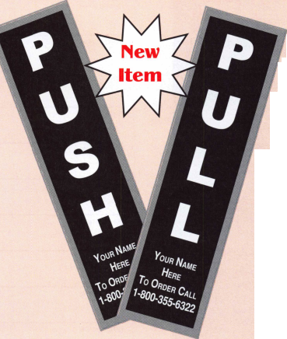

**BOARD**

nominations

**What ALOA Board Positions Are Open and Where Am I Qualified to Run?**

**There are currently seven regional directors positions open for election in addition to the position of Secretary. ALOA members now elect the directors from their own regions. Only ALOA members from a region are eligible to run for the open posi­tional in that region. And only mem­bers from the nominee's region will receive a ballot to vote for that can­didate. Members from any region are eligible to run for the President position. You must have been an ALOA member for at least three years to run.**

**The following vacancies will exist for the election to be held before the ALOA 2004 Convention.**

**Northeast three directors**

**South Central one director**

**Northwest one director**

**Asian one director**

**European one director**

**Secretary**

**If you have any questions, please contact Charles Gibson at (800) 532-2562 or email [charlie@aloa.org](mailto:charlie@aloa.org).**

**On this page you will find the required nomination petition and on the following page, the nomination form.**

**The following is the number of signatures required for each Board position:**

**Secretary 25**

**Northeast 22**

**South Central 7**

**Northwest 4**

**Asian 3**

**European 4**

Associated Locksmiths of America, Inc.

Board of Directors Nomination Petition

Please print legibly or type. This form can be reproduced if needed.

I, the undersigned, request that be placed on

(name of nominee and member number)

the ballot for for the election to be held at

(position for which individual is being nominated)

the special meeting of ALOA members to be held in 2004 or any adjournment thereof. I am eligible to vote in the region.



PRINTED NAME



PRINTED NAME



PRINTED NAME



PRINTED NAME



PRINTED NAME



PRINTED NAME



PRINTED NAME



PRINTED NAME



PRINTED NAME



PRINTED NAME

11

PRINTED NAME

12

PRINTED NAME



PRINTED NAME



PRINTED NAME



PRINTED NAME



PRINTED NAME



PRINTED NAME



PRINTED NAME



PRINTED NAME



PRINTED NAME

21

PRINTED NAME

22

PRINTED NAME



PRINTED NAME



PRINTED NAME



MEMBER #

MEMBER #

MEMBER #

MEMBER #

MEMBER #

MEMBER #

MEMBER #

MEMBER #

MEMBER #

MEMBER #

MEMBER #

MEMBER #

MEMBER #

MEMBER #

MEMBER #

MEMBER #

MEMBER #

MEMBER #

MEMBER #

MEMBER #

MEMBER #

MEMBER #

MEMBER #

MEMBER #

SIGNATURE

SIGNATURE

SIGNATURE

SIGNATURE

SIGNATURE

SIGNATURE

SIGNATURE

SIGNATURE

SIGNATURE

SIGNATURE

SIGNATURE

SIGNATURE

SIGNATURE

SIGNATURE

SIGNATURE

SIGNATURE

SIGNATURE

SIGNATURE

SIGNATURE

SIGNATURE

SIGNATURE

SIGNATURE

SIGNATURE

SIGNATURE

PRINTED NAME

MEMBER #

SIGNATURE

YOUR COMMITMENT TO ALOA BOARD SERVICE

(Please read carefully and sign where indicated.)

The responsibilities of an ALOA board member include contributing a moderate amount of personal time, and a significant degree of professional guidance and expertise to the organization.

You will be expected to come to board meetings and the annual membership meeting. You will need to be prepared to sensibly discuss matters of great importance to your profession and participate in setting policy as part of a governing body. Your course of action during your tenure on the ALOA board should be guided by fair minded, constructive goals pertaining to matters of consequence for ALOA and for the industry. Your contributions are expected to benefit ALOA as a whole, taking individual member rights and concerns into account, but free of the taint of partisan politics or personal gain.

On a practical note: ALOA board members are expected to behave and dress professionally at all times, especially when actively representing the association. ALOA board members are required to participate in two board meetings per year, of three or four days in length, one each fall and spring. Board members are also asked to attend the annual con­vention and are required to attend the annual membership meeting. Board members may also be asked on a voluntary basis, to represent ALOA at related local, state or regional functions, including serving in the ALOA Booth and otherwise promoting ALOA. When travel is required for a board member, expenses covered by ALOA include lodging, travel and a reasonable per **diem.** The Board has stipulated that assigned travel will be reimbursed at the lesser of the 30-day advance tourist class airfare in effect at the time of travel or the current per-mile rate for travel by personal automobile. Spouse expenses, including extra room charges, etc., are the individual's responsibility.

• • •

I have read and understand the above responsibilities of an ALOA board member, and agree to commit my time and energies as needed. I certify all of the information contained on this form and supporting documentation to be true and complete.

I can be contacted with questions at:

Address Phone #

Signed:

Date

Please attach a recent photograph of yourself and retain a copy of this profile for your own files. This profile and all supporting documentation should be submitted no later than March 1, 2004:

Mail to:

Nominee Profile

Secretary of the Board of Directors  
Associated Locksmiths of America, Inc.

3003 Live Oak Street  
Dallas, TX 75204-6186  
1-800-532-2562



Association Health Plan Legislation Considered by Uninsured Task Force

The second session of the 108th Congress will convene on January 20, 2004, and will take up where the first session left off.While the Senate has not taken up the Association Health Plan legislation (Small Business Health Fairness Act of 2003, S. 545) this fall, significant discussions regarding the bill have been occurring in recent weeks. The Senate Republican Uninsured Taskforce, which consists of 10 Republican Senators, held several meetings in November to begin the process of developing "innovative and workable policy options to reduce the num­ber of uninsured and provide more affordable health care coverage options." One of these meetings focused exclusively on the merits of the AHP legislation. Joe Rossmann of Associated Builders and Contractors provided a detailed briefing to the Taskforce on why the AHP legis­lation is desperately needed to expand afford­able health benefits for workers employed in small businesses. Also participating in the meeting was Deputy Assistant Secretary of Labor Paul Zurawski, who briefed the Senators on President Bush's strong support for the AHP legislation. The taskforce also received presen­tations from opponents of the AHP legislation - Blue Cross Blue Shield Association and the National Association of Insurance Commissioners.

The deliberations of the Senate Republican Uninsured Taskforce, which are expected to con­tinue in December and January, will greatly impact the outlook for the AHP legislation in the Senate in 2004. Senate Majority Leader Bill Frist (R-TN) has indicated that the Senate will make an effort to pass legislation aimed at addressing the uninsured problem sometime next year. This will provide an opportunity to gain consideration of the AHP legislation in another forum if the Senate HELP Committee fails to take up the bill as a stand-alone measure.

Also in November, President Bush continued his efforts to push the Senate to approve the AHP legislation. After speaking in favor of the AHP legislation several times in October, the President again raised the issue during a speech in Alabama. ALOA's Coalition is work­ing with Administration officials to urge the President to continue his efforts to push the Senate to approve the AHP legislation.

Keynotes • January 2004



**RING of a KING**

Name Members

Recruited

Kwok-kei Leung 215

Henry W. Raymond 100

Yuriko Yanai 82

Mary S. Ohmit CPL 66

Charles C. Robertson CML 65

Jack Hobin CPL 51

William Lee CRL 44

Salvatore J. Dulcamara CML 41

C Allan Halverson 40

Michael B. Groves 39

Myeong-Rae Cho 38

Dana L. Barnum CML 35

Jim Williams CRL 33

Danny W. Rudd CPL 32

Larry A. Warnick CML 31

Eugene R. Altobella Sr 31

Jeanne G. Lodge CML 30

John C. Elliott Jr, CML, CPS 26

Robert D. DeWeese CML 29

Lawrence F. Smith Jr, CML 27

David M. Troiano 27

James M. Watt, CML, CPS 27

Marian M. Swann CRL 26

Robert F. Carroll CPL 26

Jeffrey S. Nunberg CML, CMS 26

J Thomas Hood CML 26

Robert W. Du man Sr, CML 25

Robert H. Stafford CML 25

John L. Shandy CML 24

Elvis D. Hammerschmidt CPL 24

Philip A. Rovenolt CPL 24

Jerome L. Cohen CML 23

Peter K. Gauthier CPL, CPS 23

Man-Soo Seo RL 23

Diana R. Barnum CRL 22

James J. Cawby CML, CPS 22

John S. Dorsey CML, CPS 20

Walter W. Lascar RL 18

Thomas G. Vandersteen CML, CPS.. 18

Keizo Takahashi CRL 18

James E. Fowler Sr, CML 18

David C. Harris CML 18

William T. Beranek 18

Takashi Kuwana CRL 18

Eugene R. Altobella Jr 18

James L. Hancock CRL 18

Ernest W. Wright 17

Peter R. Hall 17

William P. Grant CRL 17

James E. Gruber CRL 17

Joseph P. Ferrero CML 16

Gary F. Teams CPL 16

Kenneth E. Kim CRL, CPS 16

William J. McElheney CML 16

Joseph W. Whitaker CPL 16

Michael E. Jordan Jr, CML 16

Jon B. Griswold CML 16

Brian J. Reetz 16

John A. Ilk CRL, CPS 16

Russell P. Fuller CRL 16

Robert C. Rodocker CPL 15

Peter Sarailian CRL 15

Michael D. Robinson CRL 15

Daniel L. Landry Jr 15

Steve L. Cothran 15

Paul M. Souber 14

James T. Brickler CPL 14

Ken Dale 14

Joseph C. Fuller CML, CMST 13

Calvin G. Harris CML 13

Frank D. Hartung CML 13

Rolando Bouza 13

Donald H. Shiles RL 13

Richard C. Sievers 13

William J Wickward, CML 12

William J. Wickward CML 12

Raymond C. Lusk CML 12

John F. Engel CRL 12

Eric F. Veal 12

Thomas J. Demont CML, AHC 11

Basil W. Shannon CPL 11

Timothy K. Chow 11

Dale L. Knowles CPL 11

Timothy J. Moore CRL 11

Gregory L. Perry CML, CPS 1 1

James V. Hawley CRL 1 1

Gene Eldridge CPL 10

Ronald P. Riggins CML 10

Lester S. Brodsky 10

Ralph O. Warren CML 10

Larry L. Votaw CML 10

Thomas R. Smith CPL 10

Todd K. Ladwig CML, CPS 10

Kevin R. Wilson CML, CPS 10

William T. Straub CML 10

Richard T. Johnson CPL 10

Robert M. Massard CRL,AHC 10

Marian E. Sagar 10

Daniel S. Enriquez CRL 10

Brooke P. Berry CRL 10



How can I join the President's Club?

You can earn a membership in this prestigious club by recruiting  
just 10 new members for ALOA.

*Any ALOA member may participate.

What do I get?

When you recruit 10 members, you receive a  
handsome blue blazer with a President's Club crest.  
For each additional five members you recruit, you  
receive a lapel pin with gold-filled numbers, indicating,  
your recruiting successes.

You also get the satisifaction of knowing that you are  
helping your association, helping your industry grow,  
and you are helping fellow locksmiths achieve success.

How do I get started?

Mail the form below to the ALOA office for a supply of  
applications (800) 532-ALOA or FAX (2 1 4) 827-1 8 1 0.  
One President's Club credit is awarded for each new  
applicant. Credit is awarded only after the membership  
application is pproved. However, the credit will apply  
for the period in which the application is received.  
Failure to identify yourself as the sponsor on the applica-  
tion form at the time it is submitted to ALOA for process-  
ing will forfeit any credit.

|  |  |  |
| --- | --- | --- |
|  | Yes! 1 | want to join the ALOA President's Club. |
|  | Please rush me applications so 1 can start earning credit toward membership in the club! | |
| Name | | |
| Company | | |
| Address | | |
| City | State | Zip |

Mail this form to ALOA • 3003 Live Oak • Dallas, Texas 75204-6186

Classifieds



EMPLOYMENT

FKI SECURITY GROUP SEEKS QUALIFIED TECHNICIANS FOR NEW FIELD SERVICE DIVISION

In response to continuing and growing demand for field serv­ice, FKI Security Group has established the FKI Field Services divi­sion to support NKL Cash Handling products and is seeking quali­fied technicians in major metro markets. Technicians will support business development and new service contracts for NKL Cash Handling, which include electronic bill-counters or validators, dis­pensing safes and access control safes. Each field technician will be equipped with a state of the art communications system and all the necessary parts and tools to service all of FKIis security products.

The markets currently open are, Baltimore/ Washington DC, New Jersey/Metro New York, North/Central Ohio, Dallas, Hous­ton, Orlando/Central Florida, Northern California, Sacramen­to/East Bay, Southern California, Phoenix

Highly competitive compensation and a complete benefits package including health, dental, and vision insurance, 401 K plan, and fully paid expenses will be offered to qualified techni­cians. Technicians with the experience servicing safes, locks, ATMs or POS systems will be considered. This position can grow into a management position as the division expands.

Interested parties should contact Christina Lyell at 800-457- 2424 or e-mail your resume to [chrisl@fkisecuritygroup.com](mailto:chrisl@fkisecuritygroup.com)"

WANTED TO BUY/SELL

FOR SALE

Original Schlage blanks in 5-pin EF keyway or 6-pin in CE, EF, FG or G keyway at $12.50 per box of 50. Contact George Thomas at 218-724-3416 or write to 825 Woodlandd Ave., Duluth MN 55812-2168

WHOLESALE SAFE DEPOSIT LOCKS

Allied, Diebold, Herrin, Hall & Mavin, llco, Lefabure, Mosler, Precission, S&G, Security Corp., Yale. Locks from early 1900s to current. Call or email for lock type and pricing sheet. Quantity discounts. Call WBI at (954)484-2404 or email: [sales@wbi.us](mailto:sales@wbi.us)

FOR SALE

Owner retired. Framon Model 2 w/ manual and Scotsman Model 747XU w/ manual. Like new. Reed code books 1, 2, 3,

4 and 5. Call 919/676-8490.

WANTED TO BUY

Automotive transponder equipment wanted. Triax machine, T-Code, TCL, EDT Jr., RW2, A-l Pack-a-Punch. Call 877/411-5397 and ask for Bob.

BUSINESS FOR SALE

Kidd

SECURITY GROUP

101 Security Parkway • New Albany, IN 47150

STOP LOOKING!!!!!

EXPERIENCED TECHNICIANS WANTED

Lock into your future now! If you are experienced, intelligent, and desire a secure future, come join our team. We are a full service commercial/residential security service (locks, keys, safes, CCTV, access control, door related hardware). We offer: top wages, company vehicle, 401 k, paid vacation, paid holi­days, new uniforms, cross training, and job satisfaction. We are looking for the best techs who are ready to be treated and com­pensated as professionals.

Bass Security Services, Inc.

Ph#216-755-1200 ex.# 128

Fax#216-755-1220

E-MAIL / [rmesnick@bass-security.com](mailto:rmesnick@bass-security.com)

PROFESSIONAL EXPERIENCED TECHNICIAN(S) WANTED:

We are in need of 1 to 2 technicians with the ability to Sell, Install, and Service all major mfg. Hardware. We are located in Knoxville, Tennessee and service all areas of east and middle Tennessee. Must have a clean criminal and driving record. Must have profes­sional attitude and appearance. Background check and References must be supplied. Must be experienced in commercial, industrial, and residential hardware sales, service and installations. Access and other areas is a plus. Paid Holidays, Retirement, Health insurance, uni­forms, tools and truck supplied. 8-5pm Monday thru Friday.

Ph# 800-484-5577, pin 0841 Fax# 865-637-2359 E-Mail: [info@fmgeorge.com](mailto:info@fmgeorge.com)

BUSINESS FOR SALE

A small, quite successful business for sale in south Orange County, California. Three Rytan machines, three HPC code machines, HPC code books, coding program, tools for "luxury" vehicle lockouts - all parts, tools and supplies to keep two trucks on the road full time. One truck on the road provides $10-1 1K per month. Truck, which is the Ford F250 van with advertising signage, built-in work areas and cabinetry - can be part of the package or purchased separately. Low operating costs after 10 years of building the business. Advertising expenses 10 years ago? $4K per month. Now we pay a fifth of that. This is a nice set-up for someone to step in and take over. Existing accounts (which bring in about $8200/month include three in property management and eight auto dealerships. We'll work to set you up with our existing accounts. All reasonable offers will be considered. Call 949/370-9619, or fax 949/458-1733.

MOBILE LOCKSMITH BUSINESS FOR SALE

Speedex duplicator, van, tools, code books, two HPC code machines (Blitz), inventory, some hardware. $6000 (firm).

Call 601/916-6448.

LOCKSMITH FRANCHISE AVAILABLE

Low cost, complete training, national Franchise call (925) 260-7373 • [www.SpeedyLocksmiths.com](http://www.SpeedyLocksmiths.com) .

CENTRAL OREGON COAST

Well-established Lock Shop with 50 -mille AAA Contract, 24-hour Mobile Van Service, Commercial, Residential and Turn-Key Auto Shop. No pun intended! Owners will train and/or assist with the transition of this busy shop with a great location on Highway 101 in the heart of Coos Bay. Cash or contract terms. Call Realty Solu­tions LLC • Ellie Cairy 503-620-5533

Classified Advertising Policy

Classified advertising space is provided free of charge to ALOA membersand for a fee of $.60 per word**,** $ **/** 5 minimum for non-members. Classified ads may be used to advertise used merchandise and over­stocked items for sale**,** "wanted to buy" items**,** business opportunitiesemployment opportunities/positions wanted and the like. Members or non-members wishing to advertise services or new merchandise for sale may purchase a "Commercial Classified Ad" for a fee of $1.30 per word[ with a minimum of $40. Each ad will run for two issues. For blind boxes there is a $5 charge to members and non­members. All ads must be submitted in writing to the ALOA office by the fifteenth of the month**,** two months prior to issue date. Send to Keynotes Classifieds3003 Live Oak St., Dallas TX 75204-6186. ALOA reserves the right to refuse any clas­sified advertisement that it deems inappro­priate according to the stated purpose of the classified advertising section.

LOCKS, SAFES and SECURITY Electronic Infobase now available at the ***ALOA Store*** at an ALOA member discount

LSS+ is the ELECTRONIC INFOBASE edition of Locks, Safes, and Security. Locks, Safes, and Security is a treatise on the history, technology and bypass of locks and safes. It provides extremely detailed information for locksmiths and law enforcement professionals. It is comprised of FIVE volumes (LOCKSMITH VERSION) that contain as many as 4000 new images, enhanced graphics, and approximately forty hours of audio and video.

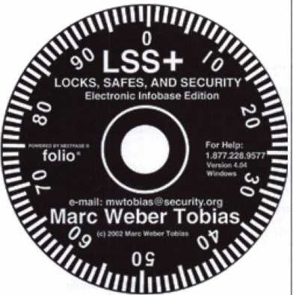

Extensive materials on forensic investigations, forced entry, and bypass of high security locks have been included. There are four books contained within the INFOBASE, including two treatises on locks and safes that were written at the height of the industrial revolution in England.

LSS+ utilizes a sophisticated search engine to instantly access the information contained within the INFOBASE. There are three security levels: PUBLIC, LOCKSMITH, and GOVERNMENT. Many chapters of the book have been expanded with text, graphics, and multimedia.

A preview copy of LSS+ is available to ALOA locksmiths. If you wish to order a preview copy, please call 800-532-2562 x23 or e- mail [orders@aloa.org](mailto:orders@aloa.org) and provide your ALOA member number. Once installed, you may view the contents for three days, without limitation. The default security level is Two, which provides access to materials restricted to locksmiths. This disk actually contains information for all security levels, but has been restricted to allow Level One and Two access only. No registration is required to preview the contents. This disk will only run on one computer after installation, without uninstalling all files. If you decide to buy the LSS+ Locksmith level collection, the other disks will be sent to you, together with a case for the preview disk. You must receive the full set prior to registration. ALOA will issue a product serial number to you prior to shipment..

After you purchase LSS+, you must pre-register at securitv.org and provide the product serial number and invoice number to prove authenticity. You can then register your copy by e-mail or by phone.

You may share your preview copy of LSS+ with others that may be interested.

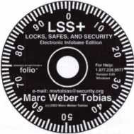

LOCKS, SAFES and SECURITY on CDRom  
now available at the ***ALOA Store***at an ALOA member discount

|  |  |  |  |  |
| --- | --- | --- | --- | --- |
|  | ass | o c | i a 1 | ■ e |
|  | m | e m b | e r s |  |

Distributor

ADI Inc.

Phone: 631-692-1000 Fax: 631-692-3011

Accredited Lock Supply Co.

Phone: 201-865-5015 Fax: 201-865-0030 [www.acclock.com](http://www.acclock.com)

Ace Lock & Security Supply

Phone: 908-688-7666 Fax: 908-688-2442 [www.acelock.com](http://www.acelock.com)

Andrews Wholesale Lock Supply

Phone: 717-272-7422 Fax: 717-274-8659 [www.andrewslock.com](http://www.andrewslock.com)

Boyle & Chase Inc.

Phone: 800-325-2530 Fax: 800-205-3500 [www.boyleandchase.com](http://www.boyleandchase.com)

Chinrose International

Phone: 503-357-7553 Fax: 503-357-5522 [www.chinrose.com](http://www.chinrose.com)

Clark Security Products

Phone: 800-854-2088 Fax: 619-974-5284 [www.clarksecurity.com](http://www.clarksecurity.com)

Cook's Building Specialties

Phone: 505-883-5701 Fax: 505-883-5704

Dire's Lock & Key Company

Phone: 303-294-0176 Fax: 303-294-0198

Direct Security Supply; Inc.

Phone: 800-252-5757 Fax: 800-452-8600

Doyle Security Products

Phone: 800-333-6953 Fax: 612-521-0166 [www.doylesecurity.com](http://www.doylesecurity.com)

Dugmore and Duncan, Inc.

Phone: 888-384-6673 Fax: 888-329-3846

E. L. Reinhardt Co., Inc.

Phone: 800-328-1311 Fax: 651-481-0166 [www.elreinhardt.com](http://www.elreinhardt.com)

Ewert Wholesale Hardware

Phone: 800-451-0200 Fax: 708-597-0881

Fairway Supply, Inc.

Phone: 214-350-0021 Fax: 214-352-4299 [www.fairwaysupply.com](http://www.fairwaysupply.com)

Foley-Belsaw Company

Phone: 800-821-3452 Fax: 816-483-5010 [www.foley-belsaw.com](http://www.foley-belsaw.com)

Fried Brothers Inc.

Phone: 800-523-2924 Fax: 215-592-1255 [www.fbisecurity.com](http://www.fbisecurity.com)

H L Flake Co.

Phone: 800-231-4105 Fax: 713-926-3399 [www.hlflake.com](http://www.hlflake.com)

H.S. & S. Wholesale Distrib.

Phone: 313-342-6777 Fax: 313-342-7580

Hans Johnsen Company

Phone: 214-879-1550 Fax: 214-879-1530 [www.hjc.com](http://www.hjc.com)

Hardware Agencies, Ltd.

Phone: 416-462-1921 [www.hardwareagencies.com](http://www.hardwareagencies.com)

IDN Incorporated

Phone: 817-421-5470 Fax: 817-421-5468 [www.idn-inc.com](http://www.idn-inc.com)

Intermountain Lock & Supply

Phone: 800-453-5386 Fax: 801-485-7205 [www.intermountainlock.com](http://www.intermountainlock.com)

Jo Van Distributors

Phone: 416-752-2238 Fax: 416-752-7282 [www.jovanlock.com](http://www.jovanlock.com)

KeylessRide

Phone: 877-619-3136 Fax: 409-216-5058 [www.keylessride.com](http://www.keylessride.com)

Lockmasters, Inc.

Phone: 859-885-6041 Fax: 859-885-7093 [www.lockmasters.com](http://www.lockmasters.com)

Locks Company

Phone: 800-288-0801 Fax: 305-949-3619

Locksmith Ledger International

Phone: 770-886-0800 Fax: 770-889-7703 [www.lledger.com](http://www.lledger.com)

M. Zion Company

Phone: 212-349-8677 Fax: 212-964-0495 [www.mzion.com](http://www.mzion.com)

McDonald Dash Locksmith Supp

Phone: 800-238-7541 Fax: 901-366-0005 [www.mcdonalddash.com](http://www.mcdonalddash.com)

McManus Locksmith Supply, Inc.

Phone: 704-333-9112 Fax: 704-332-8664

Monaco Lock Co.

Phone: 800-526-6094 Fax: 800-845-5625 [www.monacolock.com](http://www.monacolock.com)

Omaha Wholesale Hardware

Phone: 800-238-4566 Fax: 402-444-1664 [www.omahawh.com](http://www.omahawh.com)

Phoenix Safe International LLC

Phone: 765-483-0954 Fax: 765-483-0962 [www.phoenixsafeusa.com](http://www.phoenixsafeusa.com)

Professional Business Products

Phone: 248-360-3979

Fax: 248-360-3982

[www.professionalbusinessproducts](http://www.professionalbusinessproducts).

RA-Lock Company

Phone: 972-775-6301 Fax: 972-775-6316 [www.ralock.com](http://www.ralock.com)

S J Hope Products

Phone: 702-260-7645 Fax: 702-837-1465

SNA Inc.

Phone: 678-206-0381 Fax: 678-206-0382 [www.sungil-safe.com](http://www.sungil-safe.com)

SecureRite.Com

Phone: 800-241-3930 Fax: 858-974-5269 [www.SecureRite.Corn](http://www.SecureRite.Corn)

Security House

Phone: 905-669-5300 Fox: 905-660-6313 [www.securityhouselock.com](http://www.securityhouselock.com)

Security Lock Distributors

Phone: 800-847-5625 Fax: 800-878-6400 [www.securadealer.com](http://www.securadealer.com)

Sentry Security Fasteners

Phone: 309-693-2800 Fax: 800-693-2872

Somerset Security Products

Phone: 800-881-5206 Fax: 800-206-9949

Southern Lock and Supply Co.

Phone: 727-541-5536 Fax: 727-544-8278 [www.southernlock.com](http://www.southernlock.com)

Stone & Berg Wholesale

Phone: 800-225-7405 Fax: 800-535-5625

The Locksmith Store Inc.

Phone: 847-364-5111 Fax: 847-364-5125 [www.locksmithstore.com](http://www.locksmithstore.com)

Timemaster Inc.

Phone: 859-259-1878 Fax: 859-255-0298 [www.time-master.com](http://www.time-master.com)

Top Notch Distributors, Inc.

Phone: 800-233-4210 Fax: 800-854-4146 [www.4topnotch.com](http://www.4topnotch.com)

Turn 10 Wholesale

Phone: 800-848-9790 Fax: 800-391-4553

U.S. Lock Corp.

Phone: 800-925-5000 Fax: 800-338-5625 [www.uslock.com](http://www.uslock.com)

Wilco Supply

Phone: 800-745-5450 Fax: 510-653-5397 [www.wilcosupply.com](http://www.wilcosupply.com)

Manufacturer

A & B Safe Corporation

Phone: 800-253-1267 Fax: 856-863-1208 [www.a-bsafecorp.com](http://www.a-bsafecorp.com)

ABUS Lock Company

Phone: 800-352-2287 Fax: 602-516-9934 [www.abus.com](http://www.abus.com)

Abloy Door Security

Phone: 800-465-5761 Fax: 514-335-0430 [www.abloy.com](http://www.abloy.com)

Adams Rite Mfg Company

Phone: 800-872-3267 Fax: 800-232-7329 [www.adamsrite.com](http://www.adamsrite.com)

Adesco Safe Mfg. Company

Phone: 800-694-9340 Fax: 562-408-6427 [www.adesco.com](http://www.adesco.com)

Adrian Steel Company

Phone: 800-677-2726 Fax: 517-265-5834 [www.adriansteel.com](http://www.adriansteel.com)

Alarm Lock Systems Inc.

Phone: 800-252-5625 Fax: 516-789-3383 [www.alarmlock.com](http://www.alarmlock.com)

All Five Tool Company, Inc.

Phone: 860-583-1691 Fax: 860-583-4516 [www.all5tool.com](http://www.all5tool.com)

American Lock Company

Phone: 708-534-2000 Fax: 708-534-0531 [www.armericanlock.com](http://www.armericanlock.com)

American Security Products

Phone: 909-685-9680X1083 Fax: 909-685-9685 [www.amsecusa.com](http://www.amsecusa.com)

BWD Automotive

Phone: 334-872-6524 Fax: 334-874-601 1 [www.bwdautomotive.com](http://www.bwdautomotive.com)

Baldwin Hardware

Phone: 610-796-4012 Fax: 610-796-4493 [www.baldwinhardware.com](http://www.baldwinhardware.com)

Be-Tech Security Systems Ltd.

Phone: 852-231-67447 [www.be-tech.com.hk](http://www.be-tech.com.hk)

Bianchi USA, Inc.

Phone: 800-891-2118 Fax: 216-803-0202

Buddy Products

Phone: 800-886-8688 Fax: 312-733-8356 [www.buddyproducts.com](http://www.buddyproducts.com)

CCL Security Products

Phone: 800-733-8588 Fax: 847-537-1800

COMPX Security Products

Phone: 864-297-6655 Fax: 864-297-9987 [www.nclnet.com](http://www.nclnet.com)

Curtis Industries,

A Barnes Distributor

Phone: 800-555-5397 Fax: 800-867-6020 [www.curtisindustries.com](http://www.curtisindustries.com)

D&D Technologies (USA), Inc.

Phone: 714-677-1300X292 Fax: 714-677-1299 [www.ddtechusa.com](http://www.ddtechusa.com)

DETEX Corporation

Phone: 800-729-3839 Fax: 830-620-6711 [www.detex.com](http://www.detex.com)

DORMA Architectural Hardware

Phone: 717-336-3881 Fax: 717-336-3500 [www.dorma-usa.com](http://www.dorma-usa.com)

Datakey Electronics

Phone: 800-328-8828 Fax: 866-289-4212 www. d a ta keye lectrnics.com

Don-Jo Manufacturing, Inc.

Phone: 978-422-3213 Fax: 978-422-3467 [www.don-jo.com](http://www.don-jo.com)

Door Controls International

Phone: 800-742-3634 Fax: 800-742-0410 [www.doorcontrols.com](http://www.doorcontrols.com)

ESP Lock Products Inc.

Phone: 978-562-3481 Fax: 978-562-9859

FireKing Security Products

Phone: 800-457-2424 Fax: 800-896-6606 [www.fireking.com](http://www.fireking.com)

Framon Manufacturing Company Inc.

Phone: 989-354-5623 Fax: 989-354-4238 [www.framon.com](http://www.framon.com)



Keynotes • January 2004

associate

members

HES, Inc.

Phone: 623-582-4626 Fax: 623-582-4641 [www.hesinnovations.com](http://www.hesinnovations.com)

HPC, Inc.

Phone: 847-671-6280 Fax: 847-671-6343 [www.hpcworld.com](http://www.hpcworld.com)

HY-KO Products Co.

Phone: 440-232-8223X3095 Fax: 440-232-8227

Hongtai Lock Co. Ltd.

Phone: 137-238-1414 Fax: 208-793-3856

INTELLIKEY Corp.

Phone: 800-226-0703 Fax: 321-724-0811 [www.intellikey.com](http://www.intellikey.com)

Jet Hardware Mfg., Co.

Phone: 718-257-9600 Fax: 718-257-0973 [www.jetkeys.com](http://www.jetkeys.com)

KABA High Security Locks

Phone: 860-621-3601 Fax: 860-621-9727 [www.kabausa.com](http://www.kabausa.com)

KABA ILCO Corp.

Phone: 252-446-3321 Fax: 252-446-4702 [www.kaba-ilco.com](http://www.kaba-ilco.com)

KEY-BAK/West Coast Chain Mfg.

Phone: 909-923-7800 Fax: 909-923-0024 [www.keybak.com](http://www.keybak.com)

Keri Systems Inc.

Phone: 408-451-2520 Fax: 408-441-0309 [www.kerisys.com](http://www.kerisys.com)

Knaack Manufacturing Co.

Phone: 800-456-7865 Fax: 815-459-9097 [www.weatherguard.com](http://www.weatherguard.com)

MCS Communication Systems

Phone: 450-444-2040X225 Fax: 450-444-4856 [www.mcscommunication.com](http://www.mcscommunication.com)

MMD, Inc.

Phone: 865-428-361 1 Fax: 865-453-4136

MUL-T-LOCK USA, Inc.

Phone: 800-562-351 1 Fax: 973-778-4007 www. m u l-t-l oc k. com

Master Lock Company

Phone: 414-444-2800 Fax: 414-444-0322 [www.masterlock.com](http://www.masterlock.com)

Medeco Security Locks

Phone: 540-380-5000 Fax: 540-380-5010 [www.medeco.com](http://www.medeco.com)

Mustang Company

Phone: 574-674-0053 Fax: 574-675-9603

NKL Industries Inc.

Phone: 800-528-9900 Fax: 757-485-0271 [www.nklindustries.com/products_NK](http://www.nklindustries.com/products_NK)

OSI Security Devices

Phone: 619-628-1000 Fax: 619-628-1001 [www.omnilock.com](http://www.omnilock.com)

Pro Steel

Phone: 801-373-2385 Fax: 801-373-2399 [www.prosteel.us](http://www.prosteel.us)

ROFU International Corp.

Phone: 800-255-7638 Fax: 253-922-1728 [www.rofu.com](http://www.rofu.com)

Rutherford Controls Int'l. Co.

Phone: 757-427-1230 Fax: 757-427-9549 [www.rutherfordcontrols.com](http://www.rutherfordcontrols.com)

Security Solutions

Phone: 405-376-1600 Fax: 405-376-6870 [www.securitysolutions-usa.com](http://www.securitysolutions-usa.com)

Sully Tools Inc.

Phone: 703-689-3416 Fax: 703-787-0869 [www.sullytools.com](http://www.sullytools.com)

Sun Safes Manufacturing Co.

Phone: 823-194-59300 Fax: 823-194-59400 [www.eaglesafes.com](http://www.eaglesafes.com)

Taylor Security & Lock

Phone: 410-646-9900 Fax: 410-646-0045 [www.taylorsecurity.com](http://www.taylorsecurity.com)

Taymor Industries, Inc.

Phone: 800-388-9887 Fax: 800-288-8133

Townsteel, Inc.

Phone: 626-858-5080 Fax: 626-858-3393

Trine Access Technology

Phone: 718-829-2332 Fax: 718-829-6405 [www.trineonline.com](http://www.trineonline.com)

Victor E-lok, Inc.

Phone: 949-916-1200 Fax: 949-916-1300 [www.victorelok.com](http://www.victorelok.com)

Videx Inc.

Phone: 541-758-0521 Fax: 541-752-5285 [www.videx.com](http://www.videx.com)

W-LOK Corporation

Phone: 616-355-4015 Fax: 616-355-4295 [www.wlokcorp.com](http://www.wlokcorp.com)

YSG Door Security Consultants, Inc.

Phone: 800-438-1951 Fax: 800-338-0965

Service Organization

1-800 Locksmith 1994 Inc.

Phone: 800-562-5764 Fax: 718-236-4504 www. 1 800locksmith.net

Allstate Insurance Company

Phone: 800-859-0247 Fax: 847-326-7509 [www.allstate.com](http://www.allstate.com)

Cross Country Automotive Services

Phone: 800-541-2262 Fax: 781-393-0256 [www.argosi.com](http://www.argosi.com)

Emergency Road Service Inc.

Phone: 888-839-5386 Fax: 678-277-8105

Massglass & Door Service

Phone: 888-742-8837 Fax: 805-497-2255 [www.massglass.com](http://www.massglass.com)

The National Locksmith

Phone: 630-837-2044 Fax: 630-837-1210 [www.thenationallocksmith.com](http://www.thenationallocksmith.com)

The Security Professionals

Phone: 866-486-1938

Fax: 856-486-0401

[www.thesecurityprofessionals.com](http://www.thesecurityprofessionals.com)

Webster Safe & Lock Co., Inc.

Phone: 901-332-2911 Fax: 901-332-2878 [www.webstersinc.com](http://www.webstersinc.com)

LAB Security

Phone: 800-243-8242 Fax: 860-583-7838 [www.labpins.com](http://www.labpins.com)

LCN Closers/Div of Ingersoll

Phone: 815-875-331 1 Fax: 815-879-1497 [www.lcnclosers.com](http://www.lcnclosers.com)

La Gard Inc.

Phone: 310-325-5670 Fax: 310-325-5615 [www.lagard.com](http://www.lagard.com)

Lock America, Inc.

Dba L.A.I. Gro.

Phone: 714-373-2993 Fax: 714-373-2998 [www.laigroup.com](http://www.laigroup.com)

Lucky Line Products, Inc.

Phone: 858-549-6699 Fax: 858-549-3241 [www.luckyline.com](http://www.luckyline.com)

M.A.G. Security

Phone: 714-891-5100 Fax: 714-892-6845 [www.magsecurity.com](http://www.magsecurity.com)

MARKS, U.S.A.

Phone: 516-225-5400

STRATTEC Security Corp.

Phone: 414-247-3415 Fax: 414-247-3692 [www.strattec.com](http://www.strattec.com)

Sargent & Greenleaf, Inc.

Phone: 859-885-9411 Fax: 859-885-3063 [www.sargentandgreenleaf.com](http://www.sargentandgreenleaf.com)

Sargent Manufacturing Co.

Phone: 203-562-2151 Fax: 203-776-5992 [www.sargentlock.com](http://www.sargentlock.com)

Schlage Lock Co.

Phone: 719-264-5300 Fax: 719-264-5382 [www.schlagelock.com](http://www.schlagelock.com)

Schwab Corp.

Phone: 765-447-9470 Fax: 765-447-8278 [www.schwabcorp.com](http://www.schwabcorp.com)

Secure-UR-Home

Phone: 905-771-7300 Fax: 905-771-7304 '

Securitron Magnalock Corp.

Phone: 775-355-5625 Fax: 775-355-5636 [www.securitron.com](http://www.securitron.com)

***Corrects Door Sagging by Straightening Bent Hinges***

* **Slip Tool Over Hinge » Open Door**

**\* Presto! It's That Easy!**

* **Door Is Fixed.**

***An Easy Tool Which Will Add Profits  
To Any Locksmith's Arsenal***

**— GKL Products —**

**800-924-5397**

Fax: 516-225-6136 [www.marksusa.com](http://www.marksusa.com)

Security Door Controls

Phone: 805-494-0622

MARRAY ENTERPRISES **Fax: 805-494-8861**

Phone: 408-970-0213 [www.sdcsecurity.com](http://www.sdcsecurity.com)

Fax: 408-970-8767

[www.marray.com](http://www.marray.com)



Keynotes • January 2004

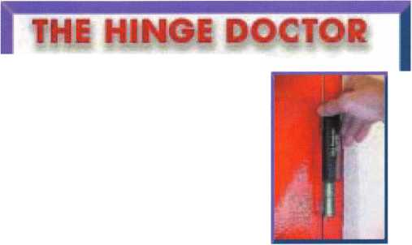

**back page**

|  |  |  |
| --- | --- | --- |
| r |  |  |
| Ad Index | |  |
| Safe Date | Inside Front Cover |  |
| Stam | 5 |  |
| DHI | 7 |  |
| Turn 10 | 9 |  |
| TLA | 11 |  |
| Lockmasters | 26 |  |
| Professional Business Products 35 | |  |
| Hinge Doctor | 43 |  |
| Clearstar Network | Back Page |  |
| Hickok | Back Cover |  |
| L |  | A |

About the Authors

Chris Geary, CRL, is an institutional locksmith at NASA Ames  
Research Center in the San Francisco bay area.

Jim Hancock, CRL, began his locksmithing career at the age  
of 8 in his grandfathers lock shop in Gulfport, Mississippi. He  
has been working as a locksmith since 1974. He currently is  
the manager of Cothron's Lock & Safe and the lead instructor  
of Cothron's School of Professional Locksmithing in Austin,  
Texas. Jim has taught for many regional associations and is an  
ALOA Certified Instructor who teaches at ALOA conventions and  
at ACE classes throughout the country.

Merritt Perkins, RL, has been a developing member of the  
locksmith and electronics industries for many years. He owns  
and operates Merritt L. Perkins Labs in Three  
Rivers, Ml.

\

You need it When?

**How about now!? :-)**

ClearStar ft  
Se«orkV

Another Special  
Value-added Benefit to your

ALOA Membership!  
Click here .

|  |  |  |
| --- | --- | --- |
|  | [www.clearstar.com](http://www.clearstar.com) / ALOA  V J |  |
|  |  | ) |

Greg Perry, CML, CPS, has been in the lock­smith industry for 20 years. He's spent half of that time as a field technician for Security Engineering in Ridgecrest, CA. Greg is also a past president of the Desert Counties Chapter of the California Locksmiths Association. He has also won the 2002 and 2003 Keynotes Author of the Year Award. You can e-mail him at [glmperry@iwvisp.com](mailto:glmperry@iwvisp.com).

Tom Seroogy is in the new Automotive divi­sion of Lockmasters. He has been the Product Manager for BWD Automotive (formerly known as All Lock). His many years of techni­cal expertise in the automotive field and as a contributor to automotive locksmith education have created a much sought after demand for his popular classes. Tom has developed the new Automotive Locksmithing I & II classes for ALOA to help prepare locksmiths for the PRP automotive electives.



Keynotes • January 2004

e/70, *Nevada: In 1859*, *Charles Fuller built a log bridge across the Truckee River and charged a fee to lose who passed over it on their way to Virginia City and the gold recently discovered there. Fuller also rovided gold-seekers with a place to rest, purchase a meal, and exchange information with other rospectors.*

*Si*

Keeping up with the latest the industry has to offer has never been more impor-  
tant for safe technicians. Time is of the essence when it comes to education. New

developments spring up each year, making top-notch safe classes as good as gold  
in our ever-changing environment. The only chance to get world-class education  
and meet with the industry's top safe technicians and suppliers is the SAFETECH  
Convention and Trade Show. SAFETECH 2004 offers you a chance to explore your  
profession in ways you never thought possible. Register now to benefit from the  
future of this exciting industry.

- *modV*

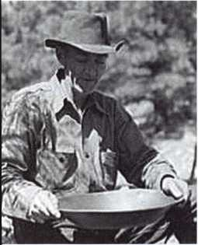

one/ vau/t incdudVby.

**SAFETECH 2004**

MARCH 20-28  
JOHN ASCUAGA'S  
NUGGET RESORT  
RENO, NEVADA

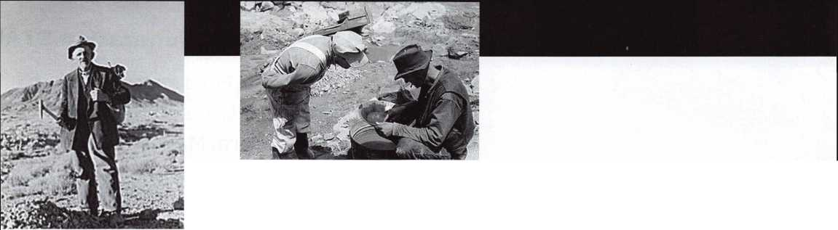

**rour Key to Unlocking Ford/Mazda**

**' 'ijjlliiHil.. illiii**1 **^ II ~ TT_tKBi**

**Transponder**

**Profits**

**You're never on your own..**

**Toll Free Tech Support**

1-800-342-5080

"I've lost my Taurus keys..

JSSj

can you make a new set?"

How much of your money  
have you sent to the  
local Ford dealer?



8008LA New Generation STA

Use the Ford factory tool to  
program transponder keys for  
ALL Ford/Mazda vehicles.

Keep the money in your pocket

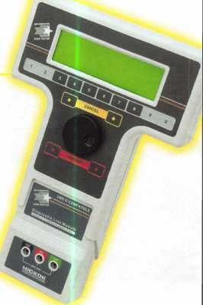

NGS

Complete

Ford/Mazda

transponder

coverage

PLUS the

ability to clear ALL

Diagnostic

Service Codes

Say "YES" to  
$100 phone calls



HICKOK

